1. Preface

This guide explains how to use Trade Innovation to process financing transactions either as independent transactions or against pre-existing trade finance transactions. It assumes that you are familiar with the basic principles of trade finance relating to financing, and with web browsers.

# About Financing

Trade Innovation financing module allows financing transactions to be entered against the following products:

* Import letters of credit
* Export letters of credit
* Reimbursements
* Import guarantees
* Export guarantees
* Import standby letters of credit
* Export standby letters of credit
* Inward clean collection orders
* Outward clean collection orders
* Inward documentary collection orders
* Outward documentary collection orders
* Clean bankers acceptances
* Invoices (discounted)
* Import open account
* Export open account

It also allows you to create financing transactions independent of any existing trade finance transaction, for example to provide packing credits for export letters of credit. If required, the trade finance transaction can then be associated with the financing transaction (using the Existing Related Reference field).

The system allows you to use the Settle event in financing transactions to settle invoices separately in advance, at maturity, or past due. When the Settle Invoice event is released, the system automatically creates a corresponding repayment to settle the discount deal, which is reduced by the same amount. Interest may be applied to discount deals settled after the due date.

Financing transactions can also be used to handle post-financing (or term refinance).

For each financing transaction the system creates a new master record which can be paid or amended independently, and transferred to a new, independent financing transaction. Financing transactions created within another transaction can also be paid from within payment events initiated for the originating transaction.

The system handles financing transactions using several different products, as shown in the following list:

* Finance Standalone
* Finance Import LC (for import letters of credit, guarantees and standby letters of credit)
* Finance Reimbursement (for reimbursement authorisations)
* Finance Export LC (for export letters of credit, guarantees and standby letters of credit)
* Finance Inward Collection
* Finance Outward Collection
* Finance Clean BA (for clean bankers acceptances)
* Finance Invoice (for discounting invoices)
* Finance Import Open Account
* Finance Export Open Account
* Finance Supply Chain Finance

Product options and product types can be used to set the basic characteristics of each financing transaction product, including:

* Whether a product type is mandatory or not
* The party to pay interest
* The interest/discount type
* If a foreign exchange deal is involved, the exchange rate to be used
* Penalty interest rate and period
* Default percentage and term (these can also be set at product type level and at customer/product type level)
* Whether a special interest rate should be applicable after past due date or not
* The rate type to be used during the term of the loan and, if different, when past due
* The grace period for past due premiums
* Whether or not the system should reject an unpaid repayment and, if so, after how long
* Whether interest accruals should take place during the main term of the loan (as well as after maturity) or not
* Whether, for financing transactions, customer markup/interest is capitalised by default (available in combination with interest is arrears)
* Whether, for financing transactions, cost of funds interest is allowed, and if so capitalised by default (available in combination with interest is arrears). Available where zone general option EnableSeparateCostOfFunds is set to Yes.
* Whether, for non-discount interest-based financing transactions, past due interest is capitalised by default

These default basic characteristics may be provided by the product type, if the financing transaction has one, otherwise by the product-level settings.

You can also define, at product and customer level, whether interest should be consolidated and, if so, the relevant transaction codes for postings.

Accounting options allow you to apportion accrued interest receivable and unearned interest by the customer and thus build up an accurate position of customer liability.

You can specify a default number of transit days for which interest will be charged on financing transactions. This default period may be defined for a particular customer or based on the location of the paying bank or the input branch processing the transaction. The default can be overridden at run time for a particular transaction.

Bills can be discounted using either the standard formula or a discount to yield formula, or they can be interest-bearing, with interest being charged in advance or in arrears. For interest-bearing transactions you can specify the schedule to be used to calculate interest. Schedules can have up to four tiers based on period or amount, with either specific interest rates, or a base rate or base rate group plus differential for each tier.

## Financing Transactions and Riba-free Financing

The system supports Riba-free financing for import letters of credit, inward documentary collection orders, export letters of credit, outward documentary collection orders and standalone financing.

This is done using the following financing products in conjunction with the facility to allow events to be flagged as provisional:

* Finance Import LC
* Finance Export LC
* Finance Inward Collection
* Finance Outward Collection
* Finance Standalone
* Finance Supply Chain Finance
* The use of provisional events allows your bank to advise its customers of costs incurred as a result of Murabahah financing calculations and to record the customer's acceptance or rejection of those costs.

Instructions on using the Finance Standalone product to process Riba-free financing are provided later in this user guide (see page 10). See the Import Letters of Credit User Guide – Trade Innovation and the *Export Letters of Credit User Guide – Trade Innovation*, for instructions on processing Riba-free financing for import and export letters of credit; and the Collection Orders User Guide – Trade Innovation for instructions on processing Riba-free financing for inward and outward collection orders.

## Finance Offers

Whilst Riba-free financing utilises the concept of ‘Finance offers’, this may also be used by your bank to notify customers of an offer of finance, or to respond to a customer’s request to finance a transaction for one of the following products:

* Import letter of Credit
* Export Letter of Credit
* Inward Clean and Documentary Collection
* Outward Clean and Documentary Collection
* Finance Standalone
* Finance Supply Chain Finance

Provisional event functionality may also be used by your bank to advise its customers of costs incurred in respect of finance deals for these products.

Instructions on using the above-mentioned products to process finance offers is provided later in this user guide (see page 10). and in the following product specific user guides:

Import Letters of Credit User Guide – Trade Innovation

*Export Letters of Credit User Guide – Trade Innovation*

Collection Orders User Guide – Trade Innovation

## Interest Income Accruals and Postings

Your bank can configure how postings for daily interest accruals for financing transactions are handled. By default, postings are made to accounts defined by SP parameters, and accruals and liability are not recorded at customer level.

The system allows your bank instead to record liability at customer level. This is done by using the system option CustIntAccrualAccType to select an account type. Once the system option has been set, postings are made to accounts of that type at individual customer level.

If your bank starts using this system option, it will need to set up the starting balances of the various customers manually. Also you will need to review the postings set up for products for which interest income accruals are generated, to ensure that the same account type is used in repayment postings as in the postings used to make accruals.

By default, customer/markup interest accruals and related cost-of-funds interest accruals are carried out for financing transactions from inception. Product types allow your bank to configure financing transactions so that accruals are not carried out during the main term of the loan, but begin once maturity is reached. This can be set to happen for customer markup interest, or for cost-of-funds interest, or for both.

## Repayment

Repayments can be scheduled to occur automatically, with separate schedules for interest and principal repayments. Repayments can also be made manually, allowing you to enter:

* A final payment
* Principal plus interest to date
* Interest to date, then principal
* Repayment of any portion of the interest or principal amounts

For repayment from within the payment events of export letters of credit or outward collection orders, you may also be able to enter a minimum repayment. (Whether this option is available or not depends on the setting of the MinimumRepaymentDefaultAmt system option.)

For financing transactions originating from within other trade finance transactions, repayment can also be made during the payment events of the originating transaction.

An Interest button (see page 41) on the Master Summary window allows you to calculate the principal and interest amounts required to make a final payment at a given future date.

A repayment notice can also be scheduled to occur a defined number of days before the repayment date. This can be used to inform the party making repayment of the amount due from them.

The system permits you to make a loan repayment with various payment actions. You can configure your system so that loan repayment is permitted only where the payment action involves a payment by defining error messages to prevent loan repayment where the payment action does not involve the receipt of funds. See the System Tailoring User Guide – Trade Innovation.

1. Financing transactions for clean bankers acceptances can only be repaid from within events for the clean bankers acceptance.

## Transferring an Advance

The system permits you to transfer the outstanding principal amount of a financing transaction over to a new financing transaction. The new transaction will be of the same type of product as the original financing transaction.

When you do this, the system matures the original transaction, calculates interest due, if applicable, and carries the total outstanding principal amount over to the new financing transaction, together with any outstanding charges.

Past due transactions can also be automatically transferred to a different area of the balance sheet a defined number of days after they become overdue.

1. You cannot transfer amounts between financing transactions for clean bankers acceptances.

## Credit Risk Management

If your bank has implemented a credit risk management application, your system will perform on-line credit limit checking as necessary as part of the life-cycle of a transaction. Depending on how your system has been configured, account manager approval for a credit line utilisation may be required always, or only when overline conditions are detected.

See the Common Facilities User Guide – Trade Innovation for more information on credit risk management.

## Participating a Financing Transaction

If you have the Trade Innovation’s participations module implemented, you can participate a financing transaction when that transaction is created. You can either use an existing participation deal, or create a new participation deal for use with that transaction. This enables your bank to share the risk on trade finance loans such as discounted acceptances, pre-export financing, or trust receipt loans.

If the amount of a financing transaction is changed by an amendment event, or by the transaction being repaid or expired, a Drawdown/Revolve Commit Amt event may be created as a subsidiary event to update the commitment amount available on the participation deal. This will occur under the following circumstances:

* If the financing transaction amount is increased, a drawdown will take place to reduce the amount available on the participation deal
* If the financing transaction amount is decreased, including being reduced to zero when the transaction is paid or transferred, a revolve will be used to increase the amount available on the participation deal only if the participation deal is defined as revolving

A Drawdown/Revolve Commit Amt event may be created by the following events:

* Amend
* Repay
* Scheduled Repayment

For a full description of using participation deals, see the Participated Deals User Guide – Trade Innovation.

## Discounting Invoices and Financing Transactions

When the Supply Chain Finance application is used to discount an invoice, the system automatically creates a financing transaction as a subsidiary event. When the invoice is paid, it automatically creates a Repay event against the financing transaction.

Financing transactions created in this way are processed automatically by the system. You can open and view them using the transaction processing application but cannot carry out any processing against them.

When discounting multiple invoices (bulk discounting) in a single finance deal, the system uses the Settle Invoice event to settle each invoice separately. The Settle Invoice event can be used for the full outstanding amount or partial payment of a specific invoice. Selection of invoices for bulk discounting is dependent whether the invoice is eligible for financing.

It is also possible to share the credit risk associated with the financing of invoices under an SCF finance deal, by automatically linking a participation deal with the related SCF programme.

Once a participation deal is linked to an SCF programme, any buyer/seller centric finance deals that are created in the SCF application under the programme, automatically include details of the related participation. This information is displayed in the ‘Participation deal / Facility’ pane. For more information about discounting multiple invoices, the eligibility criteria for financing of invoices and the linkage of participations to programmes, see the *Supply Chain Finance User Guide – Trade Innovation*.

## Licenses

The system includes facilities for the use of licenses with financing transactions. Your bank can also make returns to the central licensing authority on a regular basis to show the utilisation of the licenses issued to customers.

One or more licenses can be linked to a financing transaction and a drawdown made against the license. Full validation between the loan and license is provided to ensure that licenses do not become overdrawn.

If the amount of the loan is increased during an amendment event, then additional drawdowns can be made for the increase.

For full details of processing licenses see the Licenses User Guide – Trade Innovation.

## Export Credit Agency Facilities

The system supports export credit agency facilities, whereby an export credit agency lodges funds with your bank for the purpose of providing short-term loans to exporters who are customers of your bank.

Each such lodgement of funds is recorded in the system using a single product - the Export Credit Agency Facility product. Your bank can distinguish between different types of export credit agency facilities by setting up product types for that purpose. The system's rules facility can then be used to govern how a facility should be handled, depending on its product type.

An export credit agency facility is set up for a specific customer following agreement with the export credit agency (also known as the funding party).

Loans against an export credit agency facility are handled using financing transactions, which are linked to the relevant export credit agency facility. The facility can be set up before the financing transaction, or at the same time.

As a financing transaction is linked to a facility, the amount of the facility is reduced by an equivalent amount using an automatically generated Drawdown/Revolve Facility event.

At Product Type level it’s possible to specify the maximum percentage which may be drawn down under an export credit agency facility. This defaults in the export credit facility create event, but may be manually overridden if required.

The cost-of-funds interest payments due to export credit agencies are set up using interest types, and the scheduled interest payments are calculated and made to the funding party either automatically according to the schedule or when a repayment for an invoice is made against a linked financing transaction (this is determined by product type settings). The system uses the Settle Invoice event to settle invoices in a finance deal separately. Your bank can apply interests to past due invoices.

If regular automatic payments are used, overnight processing identifies when payment to facilities belonging to a particular product type are due and generates a single payment per facility. Each payment includes interest across all the financing transactions linked to the relevant facility.

An export credit agency facility can be blocked at any time by your bank (and subsequently unblocked) if required. This has no effect on financing transactions linked to the facility but does prevent any further financing transactions from being linked to it.

The following financing products can be linked to an export credit agency facility:

* Finance Standalone
* Finance Export LC (for export letters of credit, guarantees and standby letters of credit)
* Finance Outward Collection

### Cost of Funds Processing

For financing transactions linked to export credit agency facilities the system allows your bank to define two separate forms of interest:

* Interest for your bank
* Interest levied to meet the cost of funds for the export credit agency

The functionality that allows this is enabled using the zone general system option EnableSeparateCostOfFunds.

Interest for your bank can be capitalised in the same way as customer markup interest. When capitalising the full interest to be deducted from the customer, both of the following tick-boxes should be checked:

Capitalise customer/markup interest

Capitalise customer cost of funds interest

Interest levied to meet the cost of funds for the export credit agency is against an agreed cost. This interest cannot be capitalised.

Both types of interest are set up using interest types.

1. To use the cost of funds functionality, the below setup should be followed:  
   The standard interest type should not be used in conjunction with the cost of funds type.   
     
   The Bank should define a combination of the following interest types:  
   **Cost of funds:** to represent the interest cost from the funding party to the Trade team.   
   **Markup:** to represent the Trade team margin on the financing.  
     
   This ensures the correct scheduling and distribution of interest.

For cost-of-funds interest your bank can define whether the interest is to be calculated and paid as each repayment event is processed; or whether it is to be handled instead by overnight processing. If the latter, at a regular frequency (defined by your bank) the system's overnight processing will calculate and pay the interest for all financing transactions so flagged, making one payment per product type per export credit agency facility. These settings are defined at product-type level, but can be overridden at individual financing transaction level and at repayment event level.

Interest types provide the schedules and default details used to calculate the interest, and these can also be overridden during transaction processing.

Cost of funds interest ceases to be calculated when a financing transaction becomes past due.

For information on setting up interest types see the System Tailoring User Guide – Trade Innovation.

## Financing Clean Bankers Acceptances

Financing transactions for clean bankers acceptances differ from other financing transactions, in that they can only be amended or repaid from within events initiated for the clean bankers acceptance, not by accessing the financing transaction master. See the Clean Bankers Acceptances User Guide – Trade Innovation for further information.

Such financing deals are treated as transactions related to the clean bankers acceptance transaction. They can be viewed by pressing **CrossRef** on the Master Summary window for the clean bankers acceptance, or opened from within the Masters window.

Once created, the financing transaction is updated and processed only by the clean bankers acceptance transaction.

1. Financing transactions for clean bankers acceptances can only be repaid from within events for the clean bankers acceptance.

You cannot transfer amounts between financing transactions for clean bankers acceptances.

## Using Trade Innovation to Process Financing Transactions

The table below list the events covered in this Guide, explaining what each event allows you to do. The table lists the names given to events when the system is delivered. Your bank can change these names once the system is installed. Consequently, the names in your version of the system may be different from the ones listed here.

There are two names for each event:

* The full name, which is displayed when you choose a new event
* The short name, which is displayed in the Work in Progress pane of the Master Summary window

This Guide uses the full name of each event, as delivered with the system.

In addition to the events listed in the table, you can also use the functionality described in the Common Facilities User Guide – Trade Innovation when processing transactions in the system.

|  |  |  |
| --- | --- | --- |
| Full Name | Short Name | What it Does |
| Adjust Finance | Adjust | Allows you to make changes to any of the information held for a financing transaction (see page 71). |
| Advise Repayment | Advise Pay | Generates a repayment notice (see page 75). |
| Amend Finance | Amend | Allows you to amend a financing transaction (see page 68). |
| Scheduled Repayment | Sched Pay | Generates an event to make a scheduled payment automatically (see page 43). |
| Create | Create | Allows you to create a financing transaction (see page 16). |
| Finance Existing Collection | Finance | Allows you to create a financing transaction from within an outward collection order's master record (see page 10). |
| Finance | Finance | Allows you to create a financing transaction from within the master record of an export letter of credit, standby letter of credit or guarantee (see page 10). |
| Past Due | Past Due | Allows you to enter the penalty interest rate to be applied for an overdue financing transaction (see page 62). |
| Repay | Repay Fin | Allows you to make a manual repayment (see page 50). |
| Past Due Transfer | Pastdue Tr | Allows you to transfer a loan to a different transaction after it becomes overdue (see page 62). |

# Initiating a Financing Transaction

Financing transactions can be created from a number of different places in the system, depending on whether they are associated with another trade finance transaction or not, and, if so, what kind of trade finance transaction.

Finance Standalone Transaction

Independent transactions are created in one of two ways:

* Using the drop-down list in the Masters window's New Masters pane to select 'Finance Standalone', then clicking **New**. Note that the Team and Behalf of branch should be selected first before selecting options from the drop-down list. The system creates a Create event at either a Log step (see page 15) or an Input step (see page 16), depending on how the Workflow orchestration controlling the event is configured. See the *Workflow Tailoring User Guide – Trade Innovation* for details
* Using a finance event from within an existing export transaction any time after the event that created it has been released

The table below indicates the points at which a financing transaction can be initiated from within each trade finance product.

When you initiate a financing transaction from within an existing transaction, the system opens the same window used at an Input step for independent financing transactions.

If you create a financing transaction from within a payment event for an import or export letter of credit, standby letter of credit, guarantee or a reimbursement you will be able to repay it as part of a subsequent payment event (provided that the loan is not a trust receipt loan), as described in Chapter 5.

Finance Supply Chain Finance

To create finance transactions for supply chain finance products:

1. Use the drop-down list in the Master window's New Masters pane.
2. Select 'Finance Supply Chain Finance'.
3. Click **New**.
4. The Team and Behalf of branch should be selected first before selecting the options from the drop-down list. The system creates a Create event at Input step, depending on how the Workflow orchestration controlling the event is configured. See the *Workflow Tailoring User Guide – Trade Innovation* for details.

## Riba-free Financing and Standalone Financing Transactions

The system supports Riba-free financing for import letters of credit, inward collection orders and standalone financing transactions. This is done using the relevant finance products in conjunction with the facility to allow events to be flagged as provisional, in order to allow your bank to advise its customers of costs incurred as a result of Murabahah financing calculations and to record the customer's acceptance or rejection of those costs.

The rest of this section explains how to process a standalone Riba-free financing transaction. See the Import Letters of Credit User Guide – Trade Innovation for instructions on processing Riba-free financing for an import letter of credit; and the Collection Orders User Guide – Trade Innovation for instructions on processing Riba-free financing for inward collection orders.

1. Your bank will need to configure the postings, charges and other release items produced on completion of a Finance Standalone Create event so that they are generated only if the Create event is not flagged as provisional; and so that, if the event is provisional, it results in the creation of an offer document for the customer. See the System Tailoring User Guide – Trade Innovation for information on using the rules facility to achieve this.

To process a standalone financing transaction with Murabahah financing, initiate a Finance Standalone Create event and specify the amount of the advance in the usual way (see page 16). The system will calculate and display the Murabahah selling price using the Finance Amount Plus Interest/Profit field.

Check the Provisional flag.

When you complete the event the system will generate an offer document for the customer.

### If the Customer Accepts the Offer

If the customer accepts the offer, open the Finance Standalone Create event. This creates a second version of the event, with details inherited from the first. Attach the acceptance document from the customer to the event following the procedure used by your bank, then uncheck the Provisional flag.

Complete the Finance Standalone Create event.

### If the Customer Wishes to Negotiate a Revised Offer

If the customer does not accept the initial offer and wishes to negotiate a revised offer, open the Finance Standalone Create event. This creates a second version of the event, with details inherited from the first. Amend the details as required, keeping the Provisional flag checked.

Complete the Finance Standalone Create event. The system will generate an offer document for the customer showing the amended offer.

This process can be repeated as many times as necessary.

### If the Customer Rejects the Offer

If the customer rejects the offer, use a Book Off event to close the Finance Standalone transaction.

### Finance To and Debit Parties

The following table shows which party the system uses as the default for the party to whom the finance amount is to be paid (the Finance To party) and the party against whom the liability for the financing transaction is to be booked (the Debit Party) when a financing transaction is initiated from within another transaction:

| Product | Event | Finance To | Debit Party |
| --- | --- | --- | --- |
| Import letter of credit/ guarantee/standby letter of credit | Claim Received Outstanding Claim | Presenting party (PRB)  Can be overridden by using the Branch product system option: ‘DefaultFinanceToAndDebitParty’ | Applicant (APP)  Can be overridden by using the Branch product system option: ‘DefaultFinanceToAndDebitParty’ |
| Export letter of credit/ guarantee/standby letter of credit | Documents Presented Outstanding Presentation | Presenting party (PRB)  Can be overridden by using the Branch product system option: ‘DefaultFinanceToAndDebitParty’ | Issuing Bank (ISS) if exists, else Received from advising bank (RAB)  Can be overridden by using the Branch product system option: ‘DefaultFinanceToAndDebitParty’ |
| Export letter of credit/ guarantee/standby letter of credit | Finance | The beneficiary. | The issuing bank. |
| Reimbursement | Claim Received Continue Claim | Depends on the payment action.  If you select 'Pay with Financing' or 'Issue Trust Receipt Loan' and press **Finance**, the system uses the applicant.  If you select any other payment actions (except 'Refuse Documents' or 'Adjust Maturity') and enter financing transaction details via the 'Finance' line the system uses the beneficiary. | Depends on the payment action.  If you select 'Pay with Financing' or 'Issue Trust Receipt Loan' and press **Finance**, the system uses the applicant.  If you select any other payment actions (except 'Refuse Documents' or 'Adjust Maturity') and enter financing transaction details via the 'Finance' line the system uses the applicant. |
| All collection orders | Discount Acceptance | The drawer. | The collecting bank. |
| Inward collection order | Payment | Remitting Bank (RBK)  Can be overridden by using the Branch product system option: ‘DefaultFinanceToAndDebitParty’ | Drawee (DRE)  Can be overridden by using the Branch product system option: ‘DefaultFinanceToAndDebitParty’ |
| Outward collection order | Create | Drawer (DRW)  Can be overridden by using the Branch product system option: ‘DefaultFinanceToAndDebitParty’ | Collecting Bank (CBK)  Can be overridden by using the Branch product system option: ‘DefaultFinanceToAndDebitParty’ |
| Outward collection order | Finance Existing Collection | The drawer. | The collecting bank. |
| Clean bankers acceptance | Create (if discounted) Purchase | The beneficiary. | The obligor. |
| Invoices (discounted) | Create Invoice Discount Invoice Settle Invoice | The invoice customer (seller) | The invoice customer (seller) |
| Finance Supply Chain Finance | Create  Repay  Advise Repay  Schedule Repay  Past Due  Book-off | Buyer | Seller |
| Seller | Buyer |
| Import Open Account | Request Payment  Continue Payment Request | Depends on the payment action.  If you select 'Pay with Financing' and press **Finance**, the system uses the buyer.  If you select 'Repay Finance' the system uses the buyer.  If you select any other payment actions (except 'Reject and enter financing transaction details via the 'Finance' line the system uses the seller.) | Depends on the payment action.  If you select 'Pay with Financing' and press **Finance**, the system uses the buyer.  If you select 'Repay Finance' the system uses the buyer.  If you select any other payment actions (except ‘Reject’ and enter financing transaction details via the 'Finance' line the system uses the buyer.) |
| Export Open Account | Payment  Continue Payment | The seller. | The obligor relating to the payment. |

## Licenses

Depending on how the product options have been set, finance transactions may be linked to licenses. If a license is required, then you must link a license to the finance transaction and make a drawdown for the amount of the loan. There will be some additional validation when creating the transaction. For example:

* The financing product type will be validated against the license. Depending on how your system is set up, it may be mandatory to have a license for the type selected
* Depending on how the license product mapping is set up, the Finance To Party may be validated against the principal party (for example Loan Party) of the license
* Depending on how the license product mapping has been set up, the Debit Party may be validated against the non-principal party (for example loan Repayment Party) of the license
* The financing deal amount will be validated against the license. If the license is not multi-currency, then the currency will also be validated. The amount for license allocation will be set to the Finance Amount
* The Start Date cannot be before the license Valid From date
* The Due Date cannot be after the license Valid To date

For full details of processing licenses see the Licenses User Guide – Trade Innovation.

## Export Credit Agency Facilities

During the Create event for a financing transaction, you can link the transaction to an export credit agency facility, provided that it is one of the following financing products:

* Finance Standalone
* Finance Export LC (for export letters of credit, guarantees and standby letters of credit)
* Finance Outward Collection

You can link the financing transaction to a facility that has already been set up, or you can enter details of a new export credit agency facility, to which the financing transaction is then linked.

When you complete the Create event for a financing transaction that has been linked to a pre-existing export credit agency facility the system automatically creates a Drawdown/Revolve Facility event against that export credit agency facility. This event is created as a subsidiary event of the financing transaction's Create event and it reduces the available amount of the facility.

If you create a new export credit agency facility from within a financing transaction the system creates two subsidiary events for the financing transaction Create event - one to create the new export credit agency facility (and its master record), and one to create a drawdown against it. These subsidiary events are validated at the same time as the financing transaction.

See the Export Credit Agency Facility User Guide – Trade Innovation for more information on how the system handles the relationship between financing transactions and export credit agency facilities.

Once a financing transaction is linked to an export credit agency facility, additional fields are present during the Create event to allow you to view and amend the rates used to calculate cost of fund interest for the funding party. Whether you are able to amend the details shown depends on the setting of the security capability UpdateFundingPartyRate.

## Logging Independent Financing Transactions

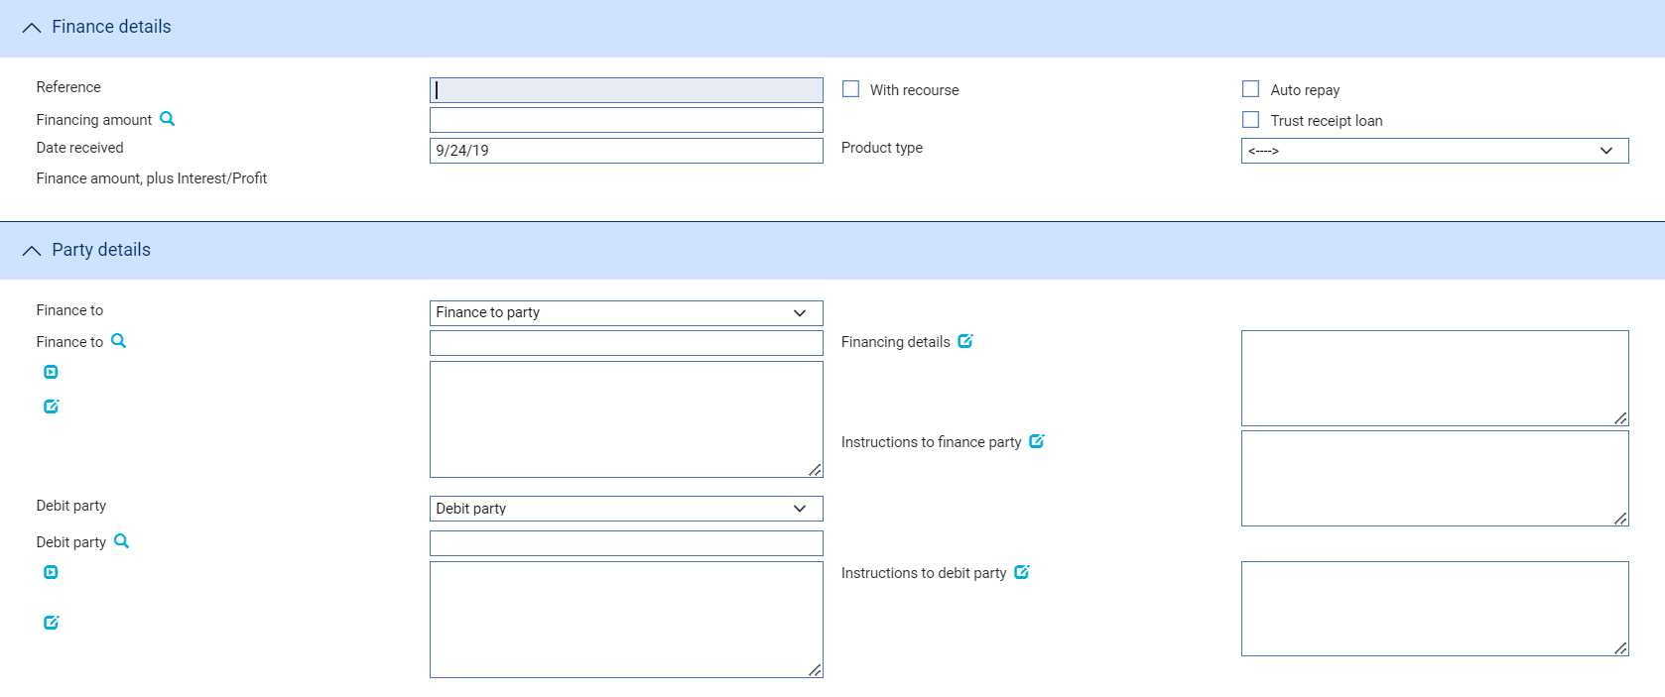

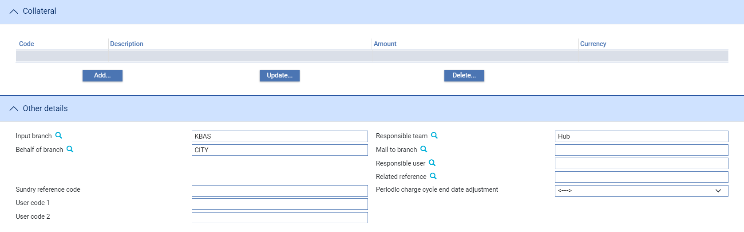

The table below explains what to enter into the fields in the window used to log an independent financing transaction:

| Field | What to Enter |
| --- | --- |
| Reference | The borrower's reference for the financing transaction. |
| Financing Amount | The amount of the financing transaction. |
| Date Received | The date the request for finance was made. The system uses today's date as the default. |
| With Recourse | Check this box if the payment is with recourse to the financing party in case of non-receipt of funds from the debit party. |
| Auto Repay | Check this box if scheduled repayments are to be processed and released automatically. If you check this box, the system generates the necessary postings for repayments automatically (provided that postings have been set up) as repayments fall due, using funds deducted from the designated account.  If you leave this box unchecked, or if insufficient funds are available in the designated account when a scheduled repayment falls due, then you will be required to process the repayment manually, as described in Chapter 4. |
| Trust Receipt Loan | Check this box if the debit party has signed a trust receipt. |
| Product Type | The type of financing transaction. This field is used to differentiate between financing transactions for the purposes of accounting, risk management and reporting. |
| Provisional | Check this box if the event is to be treated as ‘Provisional’, in which case a subsequent version of the event is required before the event can be completed. |
| Automatically create follow on event | Checking this box enables the system to automatically create a subsequent version of the event at an Input step; otherwise a new version of the event needs to be created manually. |
| Finance To | The party to whom the finance amount is to be paid. |
| Debit Party | The party against whom the liability for the financing transaction is to be booked. |
| Input Branch | The input branch for the transaction. The input branch is set from either:   * the accounting branch from the user’s team, or * the transaction branch for user if the user has a default transaction branch or is locked to a specific branch, or * a branch associated with the user where the user can enter transactions for several branches for a team |
| Responsible Team | The team that has overall responsibility for the master e.g. as the contact to resolve any queries or issues regarding the master and associated events. The system defaults the responsible team when creating the transaction as follows:   * Manual – set from team creating the transaction * Gateway – set from the team specified on the incoming message (if present and valid) otherwise to the team to which the transaction is assigned through workflow allocation based on the behalf of branch * SWIFT – set to the team to which the transaction is assigned through workflow allocation based on the behalf of branch   It can be changed, if required, to either the team associated with the primary customer, default team for the product or the user’s current team. |
| Related Reference | You can specify another transaction (including other financing transactions) to which this one relates, if you did not already do so. Use the browser to select from possible references to include. |

## Entering Full Details of a Financing Transaction

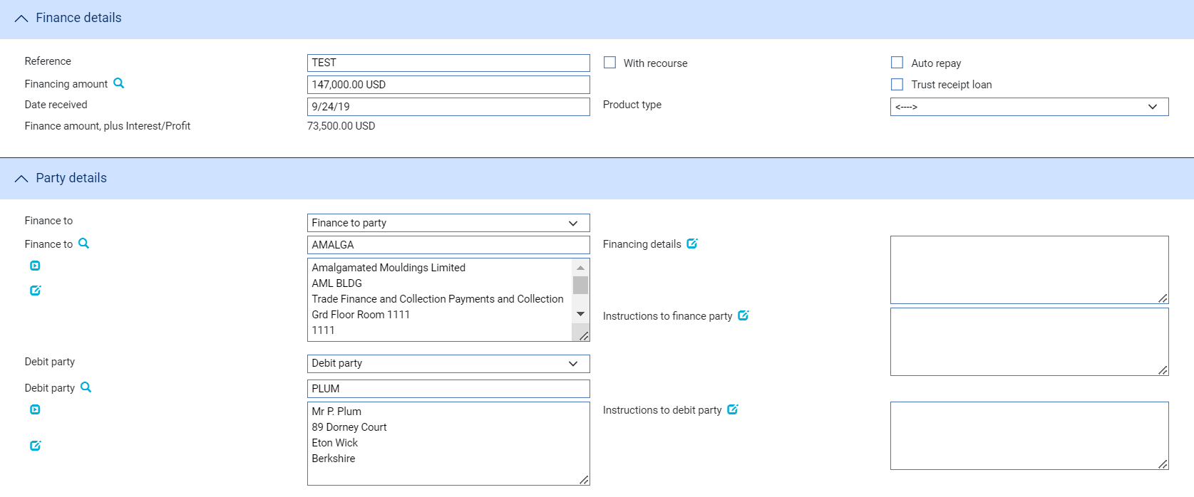

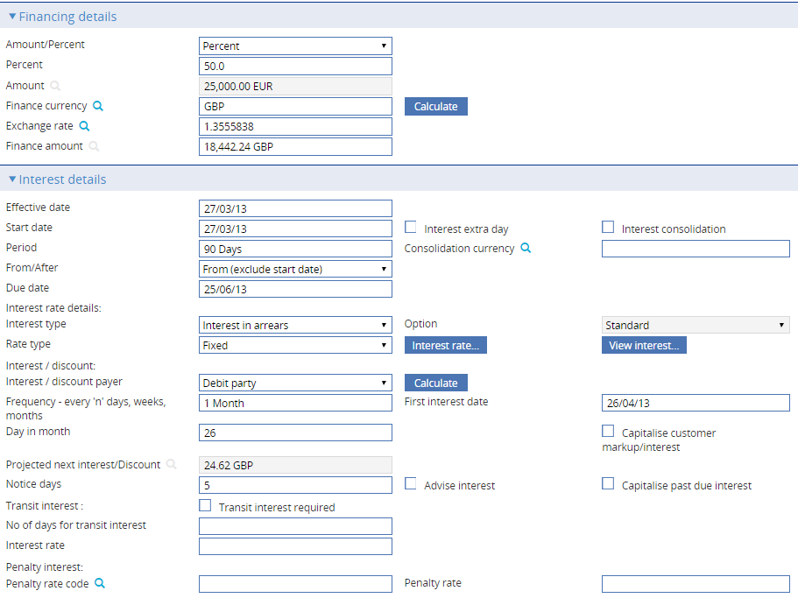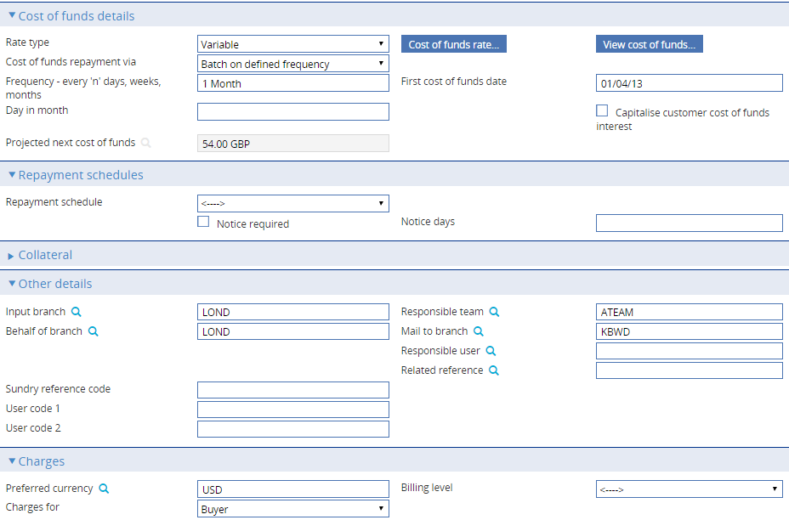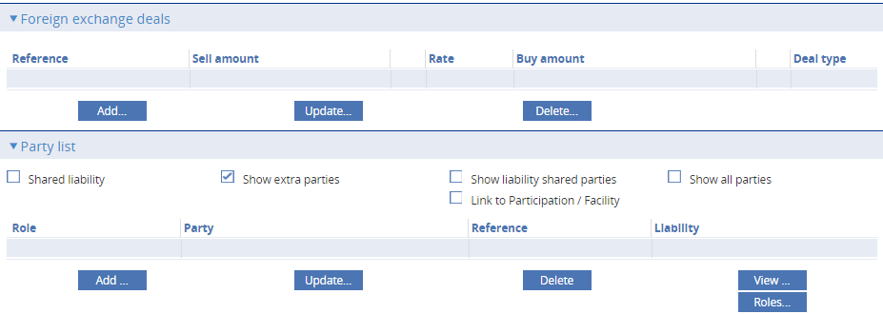

The window for Finance Supply Chain Finance has a few extra panes that corresponds to the supply chain finance details along with the other fields that exist in finance standalone product.

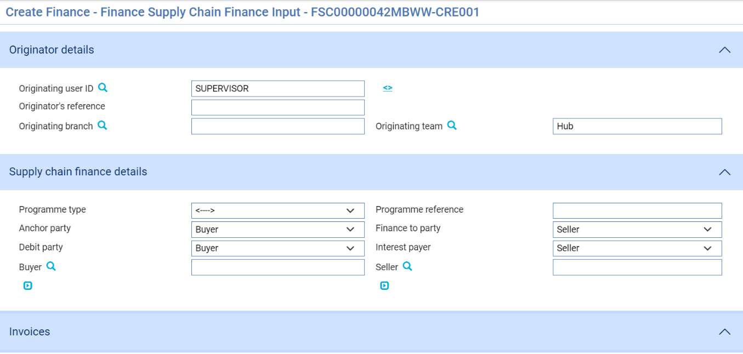

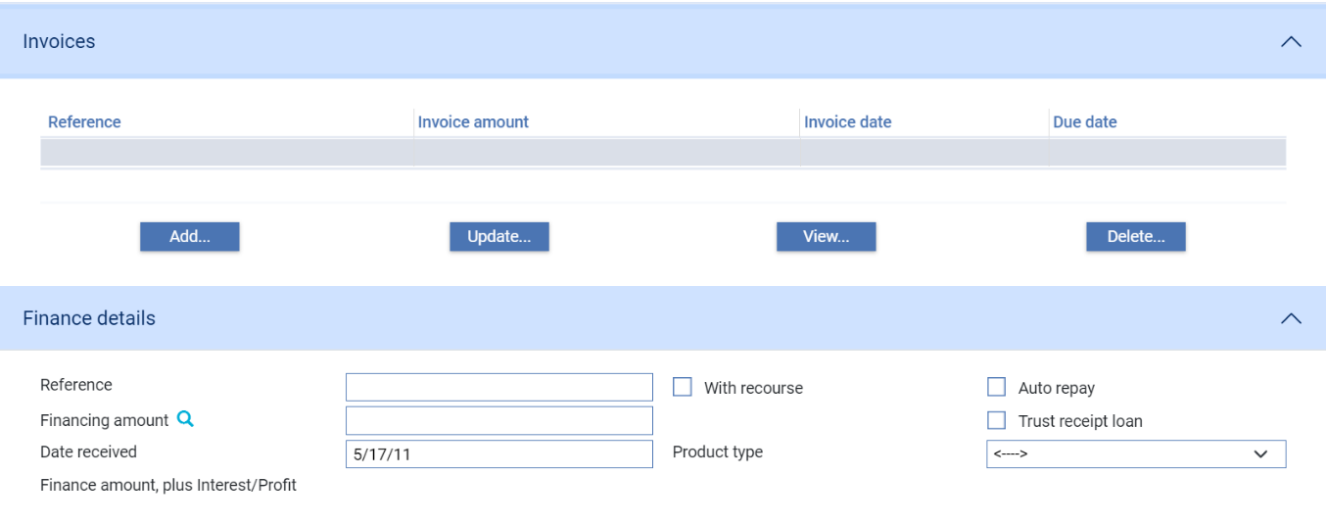

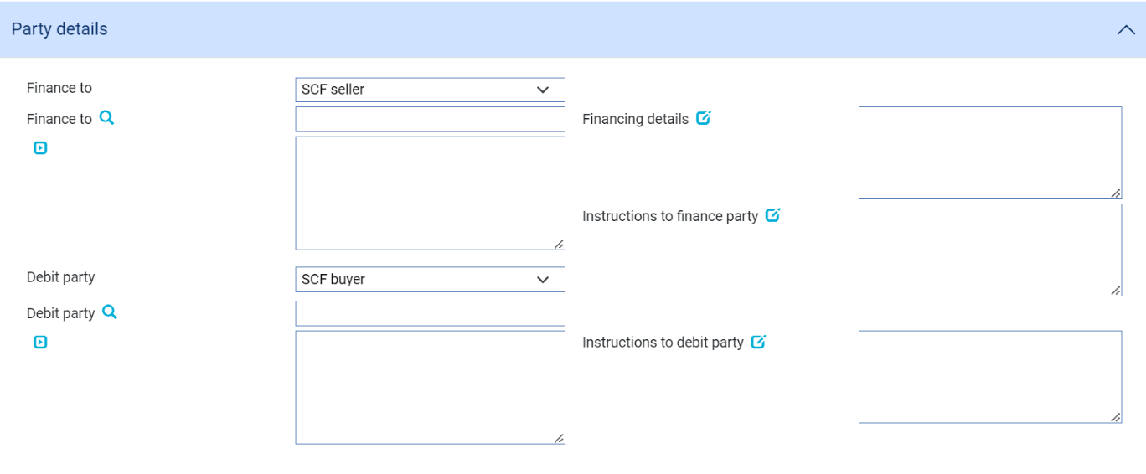

The window used to enter details of financing transactions at an Input step uses the following panes:

* The Originator Details Pane
* The Supply Chain Finance Details pane
* The Invoices Details pane
* The Finance Details pane
* The Party Details pane
* The Current Disbursements pane
* The Financing Details pane
* The Interest Details pane
* The Cost of Funds Details pane, if the financing transaction is to be linked to an export credit agency facility
* The Repayment Schedules pane
* The Collateral pane
* The Other Details pane
* The Charges pane
* The Foreign Exchange Details pane
* The Party List pane

Instructions on using the Collateral pane are given in the Common Facilities User Guide – Trade Innovation.

1. The Party List pane functionality is not available for financing transactions created from within payment events.

### The Originator Details Pane

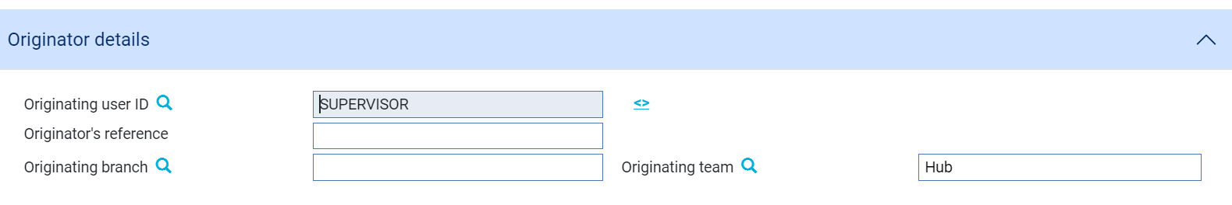

The following table explains what to enter into the fields in the Originator Details Pane

|  |  |  |
| --- | --- | --- |
|  | Field | What to Enter |
|  | Originating user ID | The unique identifier of the bank user |
|  | Originator’s reference | The reference of the bank user |
|  | Originating branch | Branch of the bank at which the transaction is created |
|  | Originating team | The name of the team set up for the bank user |

### The Supply Chain Finance Details Pane

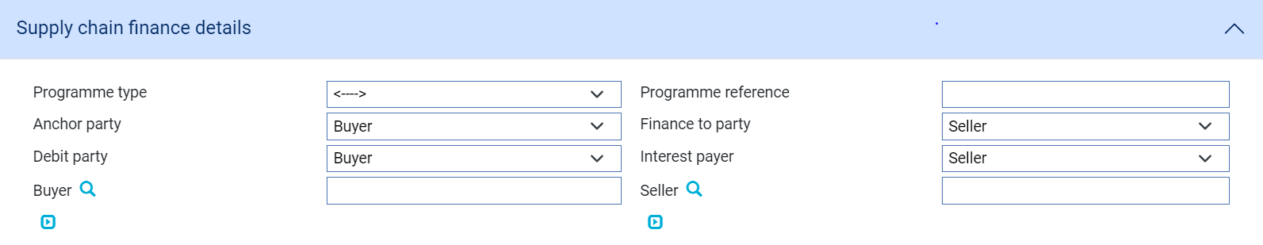

The following table explains what to enter into the fields in the Supply Chain Finance Details Pane

|  |  |  |
| --- | --- | --- |
|  | Field | What to Enter |
|  | Programme Type | Name of the programme type for which the financing is done |
|  | Programme reference | Unique reference id of the programme |
|  | Anchor Party | Specify whether Anchor party is a buyer or seller |
|  | Finance to Party | Specify whether Finance to Party is a buyer or seller |
|  | Debit Party | Specify whether Debit Party is a buyer or seller |
|  | Interest Payer | Specify whether Interest Payer is a buyer or seller |
|  | Buyer | Details of the buyer |
|  | Seller | Details of the seller |

### The Invoice Details Pane

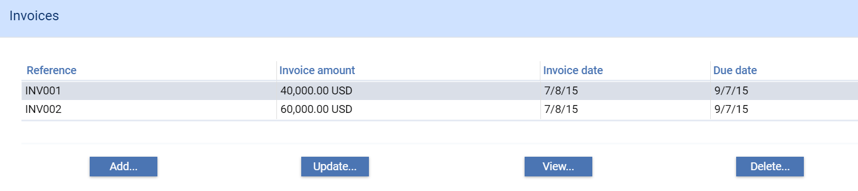The invoices against which the financing has been made will be listed in this pane. The following are the buttons available under this pane,

|  |  |
| --- | --- |
| Field | What to Enter |
| Add | Allows the user to add new invoice/invoices |
| Update | Allows the user to update or make changes in the existing invoice/invoices |
| View | Allows the user to view the attached invoice/invoices |
| Delete | Allows the user to remove the invoice/invoices from the list |

On clicking **Add** Button, the system will navigate the user to the following screen, where new Invoices can be added. After entering the details of the invoice, click **OK**. Click **Cancel** to go back to the finance create screen.

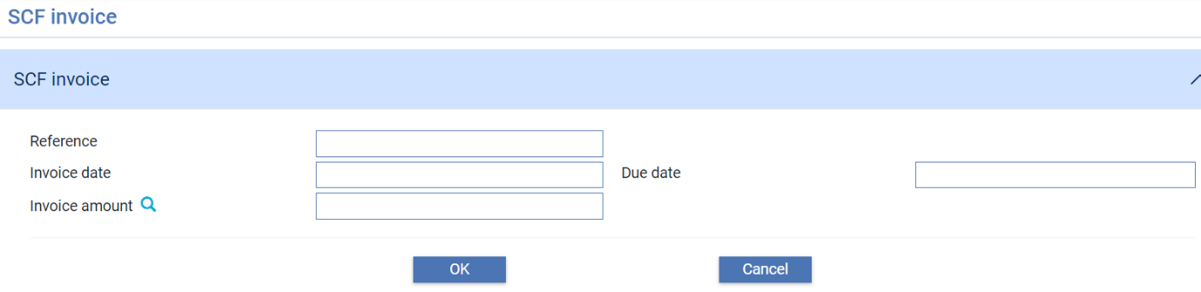

User has to select the invoice that needs to be updated. Click **Update** in the invoices pane that helps the user to update the selected invoice. Use this screen to update the invoices. After updating the values, click **OK** to accept the changes or click Cancel to go back to the finance create screen.

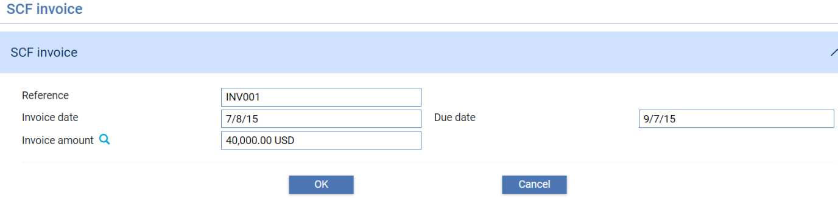

User has to select the invoice that needs to be viewed. Click **View** in the invoices pane that helps the user to view the details of the selected invoice. This screen allows the user to view invoice details. Click **Close** to go back to the finance create screen.

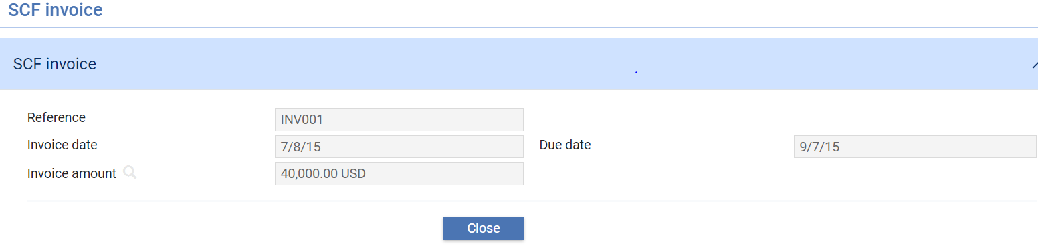

User has to select the invoice that needs to be deleted. Click **Delete** in the invoices pane that helps the user to remove the selected invoice.

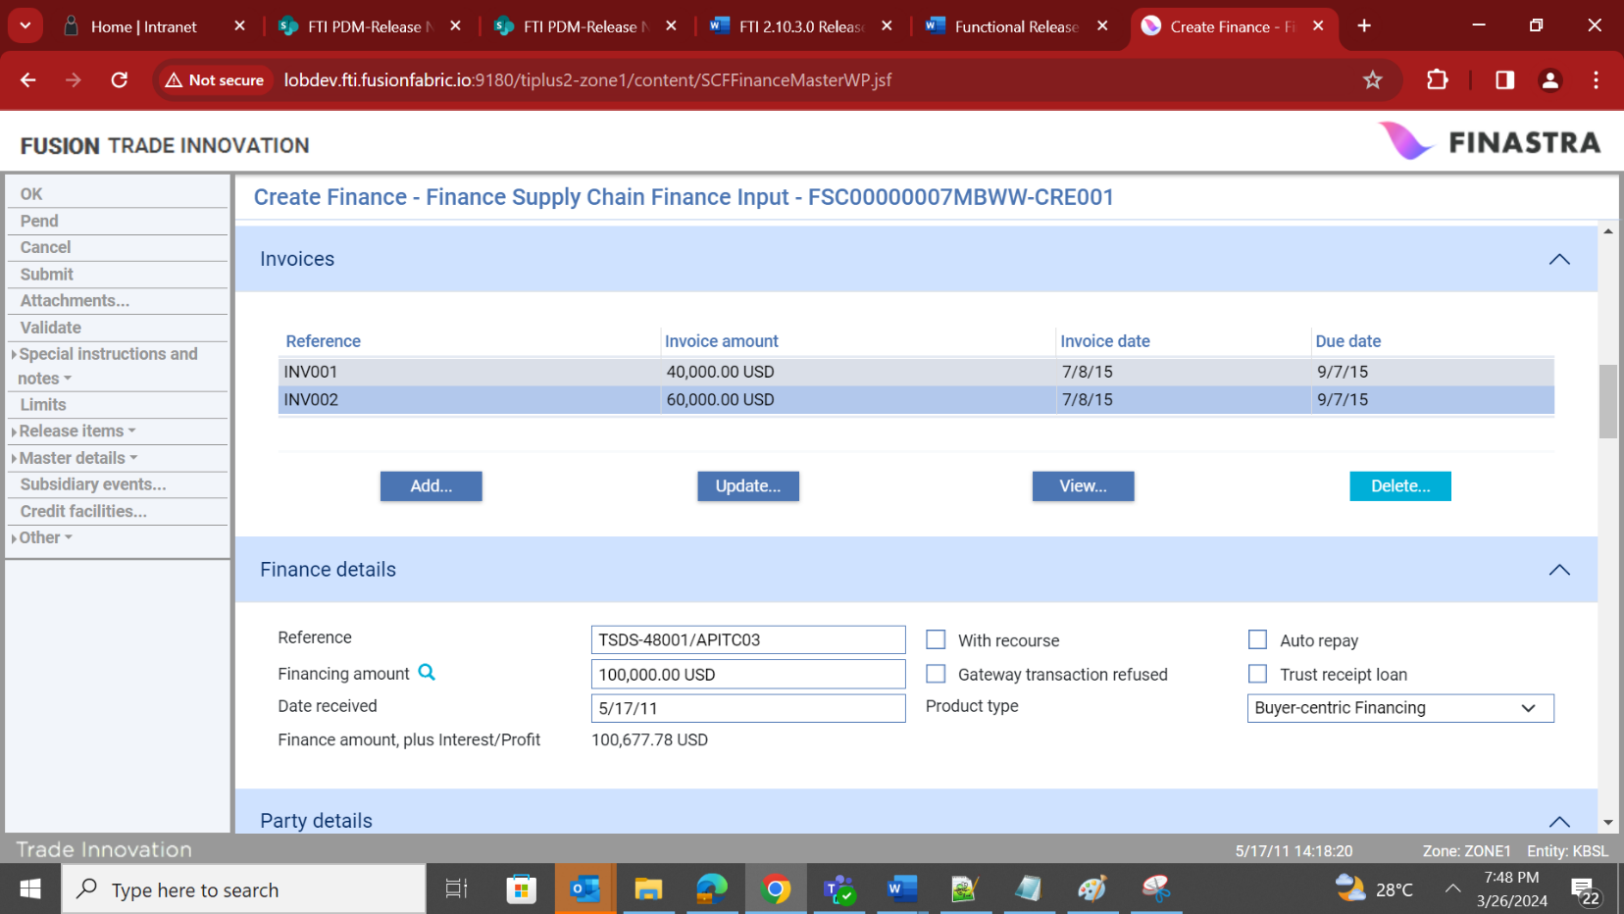

### The Finance Details Pane

Finance Standalone

The below screenshot is the pane that is displayed in finance standalone product when TFFINNEW message is processed.

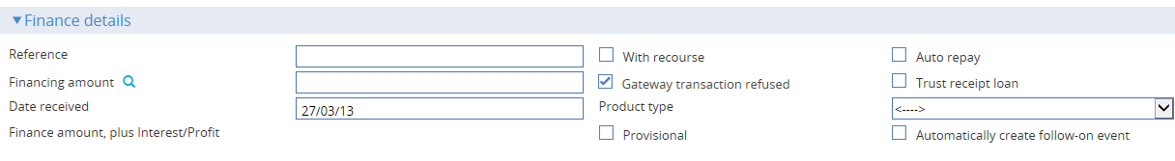

Finance Supply Chain Finance

The below screenshot is the pane that is displayed in Finance Supply Chain Finance product when TFFSCNEW message is processed.

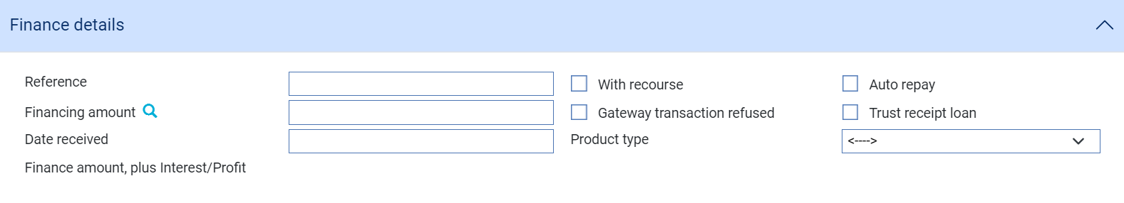

The following table explains what to enter into the fields in the Finance Details pane:

|  | Field | What to Enter |
| --- | --- | --- |
|  | Reference | The borrower's reference for the financing transaction. |
|  | Financing Amount | The amount of the advance. If you have entered one or more foreign exchange deals the system displays the total value and currency, which cannot be amended. |
|  | Date Received | The date the request for finance was made. The system uses today's date as the default. |
|  | With Recourse | Check this box if the payment is with recourse to the financing party in case of non-receipt of funds from the debit party. |
|  | Auto Repay | Check this box if scheduled repayments are to be processed and released automatically. If you check this box, the system generates the necessary postings for repayments automatically (provided that postings have been set up) as repayments fall due, using funds deducted from the designated account.  If you leave this box unchecked, or if insufficient funds are available in the designated account when a scheduled repayment falls due, then you will be required to process the repayment manually, as described in Chapter 4. |
|  | Gateway Transaction Refused | Displayed if the Financing instruction has been received via the gateway. Check this box if your bank wishes to reject the request to create the finance deal. |
|  | Trust Receipt Loan | Check this box if the debit party has signed a trust receipt. |
|  | Product Type | The type of financing transaction. This field is used to differentiate between financing transactions for the purposes of accounting, risk management and reporting.  Depending on how your system is configured, this field may be mandatory. |
|  | Provisional | Check this box if the event is to be treated as ‘Provisional’, in which case a subsequent version of the event is required before the event can be completed |
|  | Automatically create follow on event | Checking this box enables the system to automatically create a subsequent version of the event at an Input step; otherwise a new version of the event needs to be created manually. |

### The Party Details Pane

#### Finance Standalone

The below screenshot is the pane that is displayed in finance standalone product when TFFINNEW message is processed.

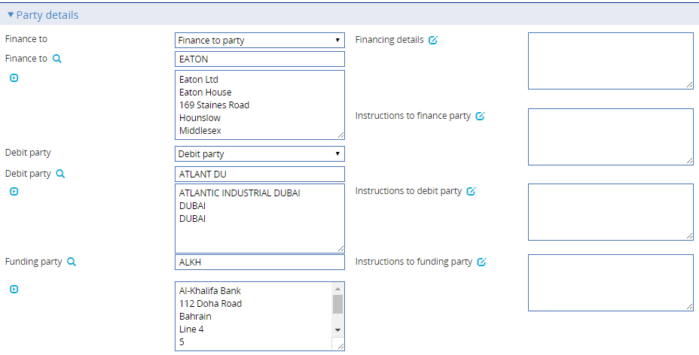

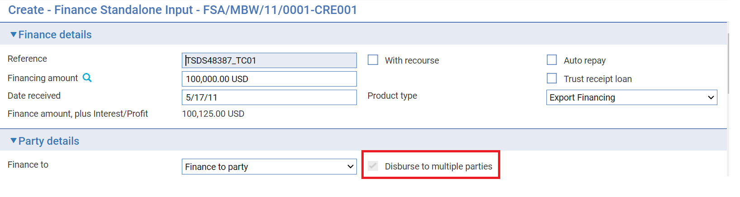

#### Finance Supply Chain Finance

The below screenshot is the pane that is displayed in finance supply chain finance product when TFFSCNEW message is processed.



The following table explains what to enter into the fields in the Finance Details pane:

|  | Field | What to Enter |
| --- | --- | --- |
|  | Finance To | The borrower. For independent financing transactions this field is initially blank. For transactions initiated from within another transaction, the system uses details taken from the originating transaction. |
|  | Disburse to multiple parties | This functionality is available only for the Finance Standalone product. It is enabled in System Tailoring > Branch Product Options > Finance Standalone and setting the option ‘AllowDisburseToMultipleParties’ to ‘Yes’  Check this box to populate ‘Current disbursements’ pane to disburse finance to multiple parties. This check box is disabled when a user manually creates a transaction and is automatically enabled and set to non-editable when a transaction is initiated via gateway message (TFFINDNEW). |
|  | Debit Party | The party against whom the liability for the financing transaction is to be booked. For independent financing transactions this field is initially blank. For transactions initiated from within another transaction, the system uses details taken from the originating transaction. |
|  | Funding Party | The export credit agency to whom the scheduled cost-of-funds interest payments are made. For independent financing transactions this field is initially blank. For transactions initiated from within another transaction, the system uses details taken from the originating transaction. |
|  | Financing Details | A narrative description of the financing transaction. |
|  | Instructions to Finance Party | Any instructions, for example terms and conditions of the financing transaction, for the borrower. |
|  | Instructions to Debit Party | Any relevant instructions for the debit party. |
|  | Instructions to Funding Party | Any instructions of the financing transaction to the funding party. |

### The Current Disbursements pane

When the checkbox Disburse to multiple parties is ticked, the ‘Current disbursements’ pane is displayed, as shown below:

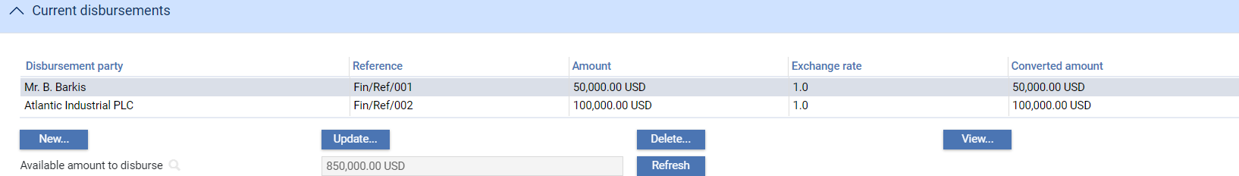

Each disbursement amount can be in a different currency.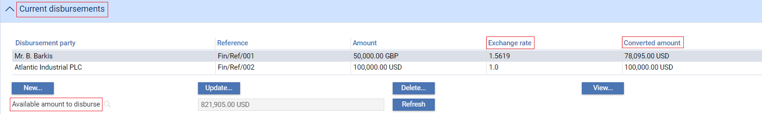

The exchange rate can be entered by the user, otherwise the spot rate from Static data maintenance will be used. The equivalent amount in the financing currency is displayed in the Converted Amount column. The values in this column are used to determine the amount remaining for disbursement to the finance to party.

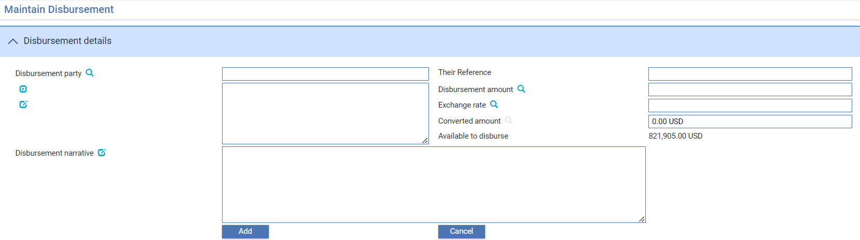

Click **New** in the Current Disbursements pane to display the screen above. It is used to manually enter Disbursement details for a Party.

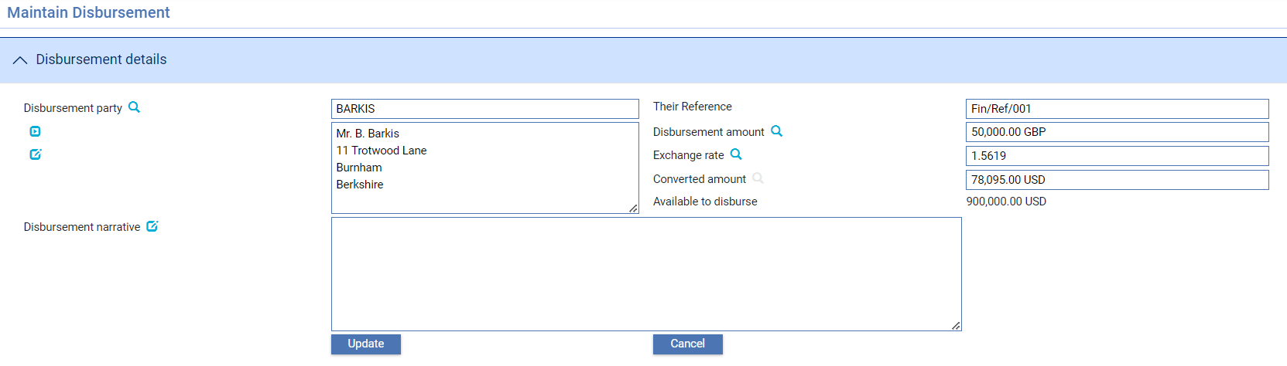

Click **Update** in the Current Disbursements pane to display the screen above. It is used to manually update Disbursement details for a Party.

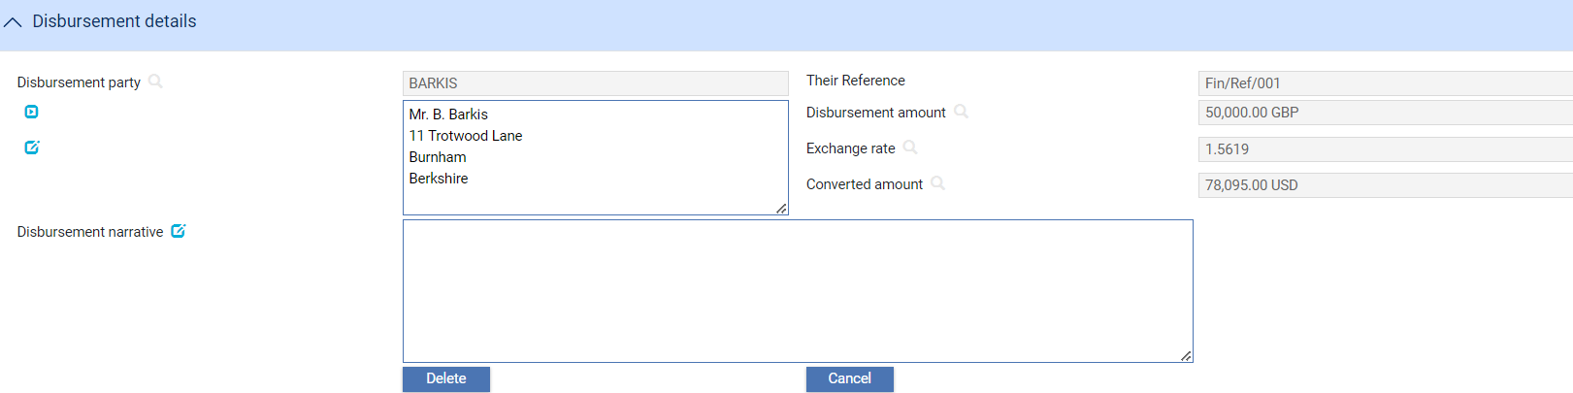

Click **Delete** in the Current Disbursements pane to display the screen above. It is used to manually delete Disbursement details for a Party.

### The Financing Details Pane

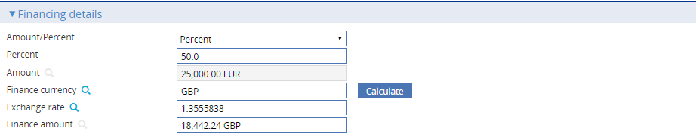

Use the fields in the Financing Details pane to indicate the amount of the advance.

If you have entered one or more foreign exchange deals the system displays their total value and currency, which cannot be amended. Otherwise use the Amount/Percent field to select whether you are defining the advance as an amount or as a percentage of the financing transaction. The system uses as the default the percentage set up for the customer for the product type. If no default has been set up for the customer it uses the default set up for the product type. If no default has been set up for the product type, it uses as the default 100%. Depending on how your system is configured, this value may be retrieved from the back office, or from defaults held on the system database.

To define the amount of the advance as a percentage, select 'Percent' in the Amount/Percent field, then enter the percentage into the Percent field.

To define the advance as an amount, select 'Amount' in the drop-down list and enter the amount into the Amount field.

You can use the Finance Currency field to select a currency for the advance that is different from the currency of the transaction. Clicking **Refresh** displays an extra field - Exchange Rate - that you can use to identify the exchange rate to be used to convert the loan amount from the financing transaction currency.

When you click **Refresh** the system calculates and displays the finance amount.

### The Interest Details Pane

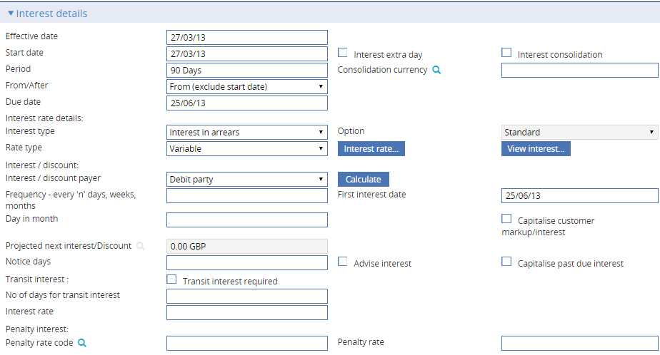

Depending on how your system is configured, the interest details displayed in the Interest Details pane may be retrieved from the back office, or from defaults held on the system database.

Interest can be defined as one of the following types:

* Interest in advance, allowing interest to be fixed for the whole term or repriced for each interest period
* Interest in advance - interest to yield, as for interest in advance, but paid at inception using the interest to yield formula
* Interest in arrears, allowing interest to be collected at maturity or periodically in arrears
* Discount, if interest is to be paid at inception using the standard discount formula
* Discount to yield, if interest is to be paid at inception using the discount to yield formula

If an interest type has been specified as part of the product type to which the financing transaction belongs, that interest type will be selected as the default value.

#### Interest in Advance or Arrears

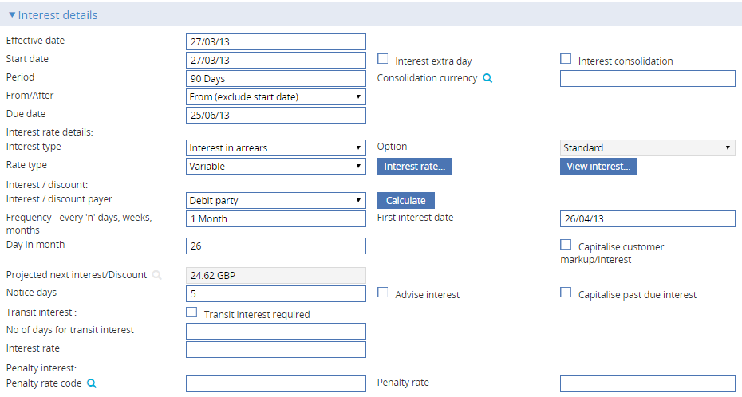

In the Interest Type field select 'Interest In Advance' or 'Interest In Arrears' and press **Calculate**. The following table explains what to enter into the fields displayed to define interest in advance or in arrears:

|  | Field | What to Enter |
| --- | --- | --- |
|  | Effective Date | The start date of the financing transaction, which cannot be later than today's date. The default is:   * For independent financing transactions, today's date * For financing for import transactions, the payment or maturity date of the originating transaction * For export transactions the base date of the originating transaction |
|  | Start Date | The start date for interest calculations, unless transit interest is to be applied. If transit interest is to be applied, then interest calculations begin after the transit period. The system uses the current processing date as the default here. |
|  |  | When the financing transaction becomes operative depends on the FinanceOperativeOnEffectiveDate system option. If this system option is set to Yes, financing transactions become operative on the Effective Date. If it not set or set to No, they become operative on the Start Date. |
|  | Period | The financing period.  The system displays as the default the values set up for the customer for the product type. If no default has been set up for the customer it uses the default set up for the product type. If no default has been set up for the product type, it leaves the fields blank.  Depending on how your system is configured, this information may be retrieved from the back office.   1. When “Interest in Arrears’ is selected this field is optional. |
|  | From/After | Indicate whether the period defined in the previous field is 'From' or 'After' the Start Date. If 'After', then the tenor will be calculated to start after the Start Date (that is, one extra day of interest). |
|  | Due Date | The due date of the financing transaction, which must be later than the start date for interest calculations.  For independent transactions and financing for import transactions this is calculated as the effective date of the financing transaction plus the financing period.  For export financing the system uses as the default value the maturity date of the originating transaction.   1. When “Interest in Arrears’ is selected this field is optional. |
|  | Interest Extra Day | Check this box if the system is to calculate and charge one extra day's interest, in addition to the term of the loan. |
|  | Interest Consolidation/Interest Consolidation Currency | If your bank has the system's interest consolidation functionality implemented, this field is displayed where interest is in arrears.  If you check this box, interest for this transaction will be consolidated and automatically debited at regular intervals.  The Interest Consolidation Currency field permits you to enter the customer's preferred currency for paying consolidated interest, which can be either the base currency or the transaction currency. Base currency is the default. |
|  | Option | Under Interest in advance select the type of interest calculation:   * Standard * Interest to yield * Discount * Discount to yield  1. When ‘Interest in Arrears’ is selected Standard is the mandatory option. |
|  | Rate Type | For interest in arrears select from one of the following:   * Fixed * Special * Variable   If a value has been set up as part of the options for the product type the system uses it as the default. |
|  | First Interest Date | The date the first interest payment is due. The default is derived from the values of ‘Day in month’ and ‘Frequency’ of the processing date or start date (whichever is later) as the base date.  Where the default falls on a non-business day and is not the end of the month, the system automatically adjusts the date based on the set-up of the *InterestSetNextCycleDate* general system option. |
|  | Interest Frequency | Define how often interest payments are to be made. If a value has been set up as part of the product type, the system uses value defined in the product type as default. |
|  | Day In Month | If you define interest frequency as being in months, or longer, enter the day of the month on which the interest is to fall due. If a value has been set up as part of the product type, the system uses value defined in the product type as the default. |
|  | Capitalise Customer Markup/Interest | For interest in arrears. Check this box if customer interest or markup above cost of funds is to be capitalised. The default can be set in the product type. |
|  | Capitalise Past Due Interest | Check this box if past due interest is to be capitalised. The default can be set in the product type. |
|  | Current Interest/ Projected Next Interest/Discount | Once you have entered details of the interest rates to be applied the system calculates and displays:   * For interest in arrears the interest amount due for the first period * For interest in advance the interest due on the first interest repayment date |
|  | Penalty Rate Code/Penalty Rate | The penalty interest rate to be applied in addition to the normal interest rate for overdue payments. Either enter a predefined code into the first field or enter the rate to be applied using the second field. If a value has been set up as part of the options for the product type the system uses it as the default. |
|  | Interest/Discount Payer | The party who will pay the interest - the credit party or the debit party. |
|  | Advise Penalty Rate | If the party paying the interest requires notice of penalty interest, check this box. |
|  | Notice Days | If the party paying the interest requires notice of penalty interest, enter the number of days prior to the date of the repayment notice is required. |
|  | Transit Interest | For interest in arrears, check the box if transit interest is to be applied. |
|  | No of Days for Transit Interest | The number of days for which transit interest is to be applied. |
|  | Interest Rate | The interest rate to be used for transit interest. |

#### Discounted Bills

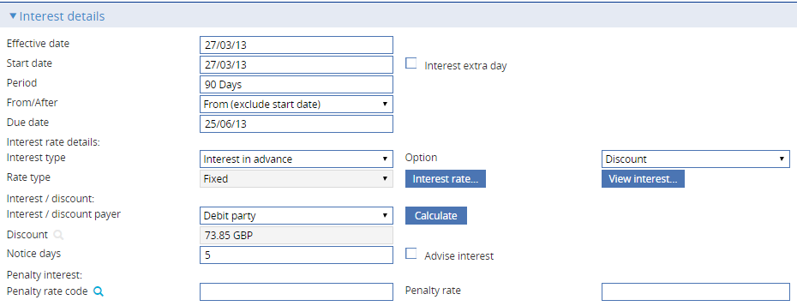

The Interest Type field must be set to 'Interest in Advance' to select Option 'Discount' or 'Discount to Yield'. When **Refresh** is clicked, the following table explains what to enter into the fields displayed to define the discount:

|  | Field | What to Enter |
| --- | --- | --- |
|  | Effective Date | The start date of the financing transaction.  For independent financing transactions the system uses today's date as the default.  For financing for import transactions, it uses the payment or maturity date of the originating transaction.  For export transactions it uses the base date of the originating transaction.  This date cannot be later than today's date. |
|  | Interest Extra Days | Check this box if the system is to calculate and charge one extra day's interest, in addition to the term of the loan. |
|  | Start Date | The start date for interest calculations unless transit interest is to be applied. If transit interest is to be applied, then interest calculations begin after the transit period.  The system uses the current processing date as the default here. |
|  |  | When the financing transaction becomes operative depends on the FinanceOperativeOnEffectiveDate system option. If this system option is set to Yes, financing transactions become operative on the Effective Date. If it not set or set to No, they become operative on the Start Date. |
|  | Period | The financing period |
|  | From/After | Indicate whether the period defined in the previous field is ‘From' or 'After' the Start Date. If 'After', then the tenor will be calculated to start after the Start Date (that is, one extra day of interest). |
|  | Due Date | The due date of the financing transaction.  For independent transactions and financing for import transactions this is calculated as the effective date of the financing transaction plus the financing period.  For export financing the system uses as the default value the maturity date of the originating transaction.  The due date must be later than the start date for interest calculations. |
|  | Discount | Once you have entered details of the discount rate to be applied the system calculates and displays the discount amount in this field. |
|  | Interest/ Discount Payer | The party who will pay the discount - the credit party or the debit party. |

#### Viewing Interest

Once you have used the Interest Rate button to define the rates to be applied to calculate interest or discount on the financing transaction, you can use the View Interest button to see what interest or discount the system has calculated.

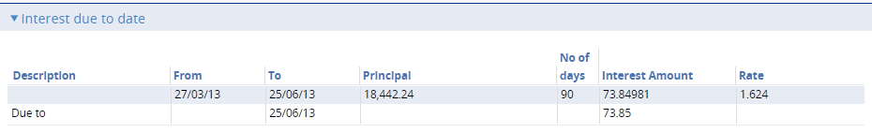

For each repayment the system displays information over two lines:

* The first line shows the start and end date of the interest period, the principal amount on which the interest or discount is calculated, the number of days in the interest period, the interest or discount amount and rate
* The second line shows the amount of interest or discount due, and the date it is due

For variable interest transactions, the first line is repeated for each interest rate period.

For participated loans, a Share button is available. If you select a line and press Share, the system displays a breakdown of the interest that is to be paid to each participant, and the amount that remains for your bank.

If more than one repayment period is shown, the Show All Periods field is displayed. By default this is blank, and only details of the current repayment period are shown. If you check this box, details of all repayment periods are shown.

If you are viewing cost of funds interest details this window is displayed using the View Cost of Funds button from within the Cost of Funds pane, and additional information is shown (see page 33).

### The Cost of Funds Details Pane

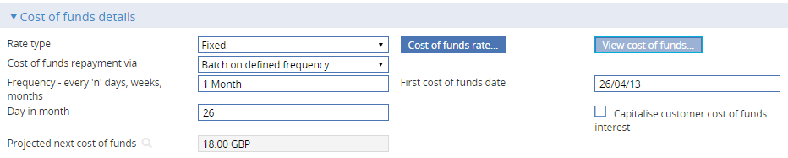

The Cost of Funds Details pane is displayed once you select a product type defined for use with financing transactions that are to be linked to export credit agency facilities. It allows you to view and amend the values used in cost-of-funds interest calculations and to define how repayments are made.

1. The security capability UpdateFundingPartyRate determines whether you are able to amend the rates used.

The Cost of Funds Repayment Via field takes its default value from the product type, and the fields displayed vary, depending on what is selected here.

In either case, a Cost of Funds button displays a second window that allows you to set up the interest rates to be used.

Once you have entered cost of funds information you can view the resulting calculations using the View Cost of Funds button (see page 33).

### Repayment Events

If repayments are to be made via repayment events against the financing transaction select 'Repayment events' in the Cost of Funds Repayment Via field.

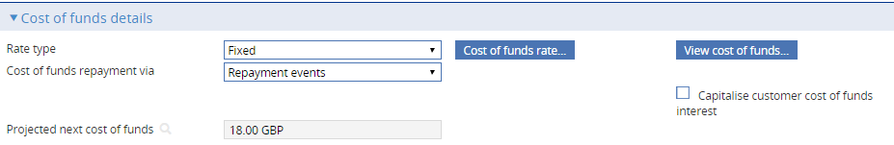

Use the Rate Type field to select the rate type to be used (the product type provides the default). Choose from:

* Fixed
* Special
* Variable

The system calculates and displays here the amount of interest due in the next repayment.

### Automatically at Regular Intervals

If repayments are to be made via repayment events against the financing transaction select 'Batch on defined frequency' in the Cost of Funds Repayment Via field.

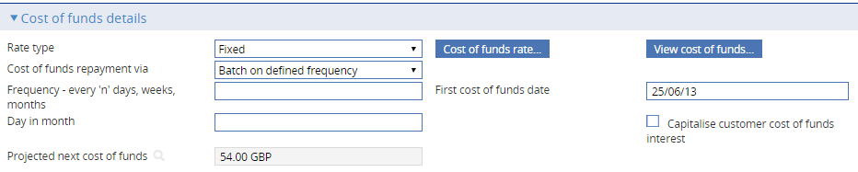

The system displays default values taken from the product type. The following table explains what to enter into the fields in this window:

|  |  |
| --- | --- |
| Field | What to Enter |
| Rate Type | The value you select here (Fixed, Variable or Special) provides the default rate type in financing transactions. |
| First Cost of Funds Date | The date on which the first cost-of-funds (COF) payment is to be made. The default is derived from the values of ‘Day in month’ and ‘Frequency’ of the processing date or start date (whichever is later) as the base date.  Where the default falls on a non-business day and is not the end of the month, the system automatically adjusts the date based on the set-up of the *InterestSetNextCycleDate* general system option. |
| Frequency | How often cost-of-funds interest is to be paid. If a value has been set up as part of the product type, the system uses the value defined in the product type as the default. |
| Day In Month | If cost-of-funds interest is to be paid at frequencies of a month or greater, enter the day of the month on which billing is to take place. If a value has been set up as part of the product type, the system uses the value defined in the product type as default. |
| Capitalise Customer Cost of Funds Interest | For interest in arrears. Check this box if the cost of funds due from the customer is to be capitalised. The default can be set in the product type. |
| Projected Next Cost of Funds | The system calculates and displays here the amount of interest due in the next repayment. |

#### Setting the Interest Rates

When you click **Cost of Funds Rate** the system displays a window used to enter details of the rates to be used.

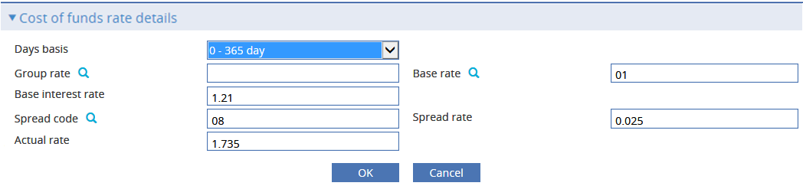

The following table explains what to enter into the fields in this window:

| Field | What to Enter |
| --- | --- |
| Days Basis | The days basis to be used to calculate the interest. A list of valid values is given in the Common Facilities User Guide – Trade Innovation. |
| Group Base Rate/Base Rate | Select either a group base rate or a base rate. If you enter a base rate, the system uses it to make the interest calculation. If you enter a group base rate instead, the system will retrieve the highest rate within that group and apply that to the transaction instead. |
| Group Base Interest Rate/Base Interest Rate | The interest rate associated with the Group Base Rate Code/Base Rate code. This rate can be overridden as required. |
| Spread Code/Spread Rate | Select either a spread code or a spread rate. The spread is then added to the base interest rate. |
| Actual Rate | Either enter an actual rate here or enter values in the Group Rate or Base Rate, Interest Rate and Spread Code and Spread Rate fields. The system then calculates and displays the actual rate used to calculate the discount. |

#### Viewing Cost of Funds Information

Once you have entered cost of funds information you can view the resulting calculations using the View Cost of Funds button.

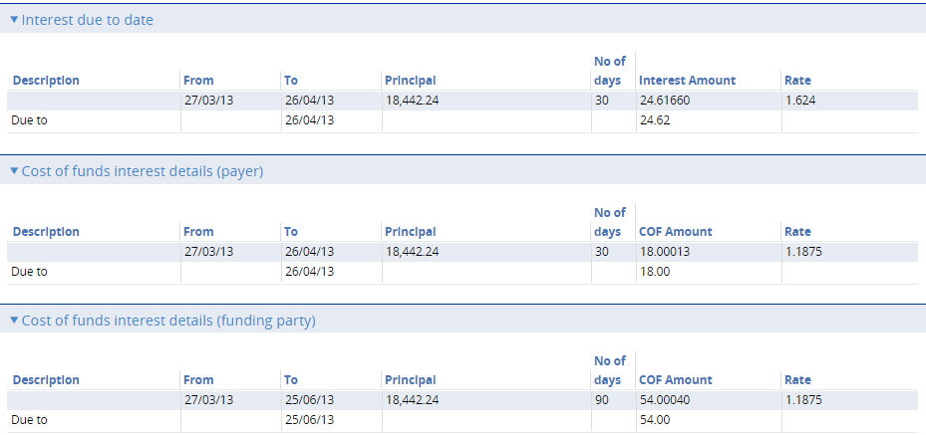

The window displayed shows details of the full markup interest to be charged to the customer, and cost of funds figures for the next interest period.

The Markup Due To Date pane shows:

* The start and end date of the period for which markup interest for the customer is calculated
* The number of days in that period
* The principal amount on which markup interest for the customer is calculated, and the actual cost of funds in the financing transaction currency
* The rate at which markup interest for the customer is calculated

The Cost of Funds Interest Details (Payer) pane shows information on the cost of funds due from the customer.

The Cost of Funds Interest Details (Funding Party) pane shows information on the cost of funds due to the funding party.

In each pane, the Due To field shows the date the cost of funds is due to be paid.

### The Repayment Schedules Pane



The Repayment Schedules pane permits you to define schedules for the repayment of principal. Schedules can be regular or irregular.

#### To Define a Regular Repayment Schedule

To define a regular repayment schedule, check the Regular box. The system displays additional fields.

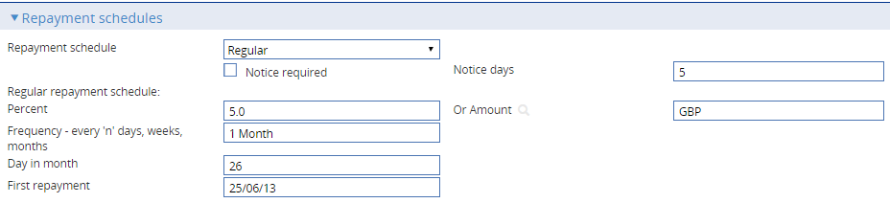

The table below explains what to enter into the fields used to define a regular repayment schedule:

|  |  |
| --- | --- |
| Field | What to Enter |
| Notice Required | If the borrower requires notification of repayments before they are due check the Notice Required box. |
| Notice Days | Indicate how soon before the repayment the notification is to be produced. |
| Percent/Or Amount | Specify the amount of each repayment. You can specify this as a percentage of the original financing transaction using the first field, or as an amount in the currency of the financing transaction using the second field.  If you enter values in both fields, the value entered the Or Amount field will be ignored. |
| Frequency | The frequency at which repayments are to be made. |
| Day in Month | If you define repayment frequency as being monthly or longer, enter the day of the month on which the repayment is to fall due. |
| First Repayment | The system applies the frequency defined in the Frequency field to today's processing date to work out the date the first repayment is due, then displays the date here.  You can overtype this date, if required. |

#### To Define an Irregular Repayment Schedule

To define an irregular repayment schedule check the Irregular check box and press **Refresh**. The system displays an additional pane.

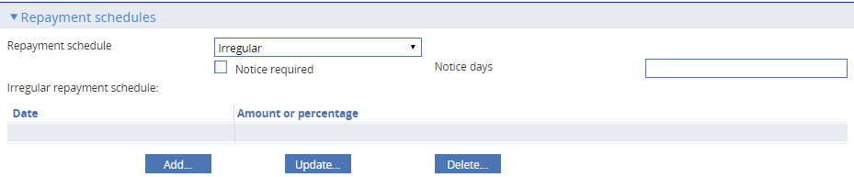

Press **Add**.

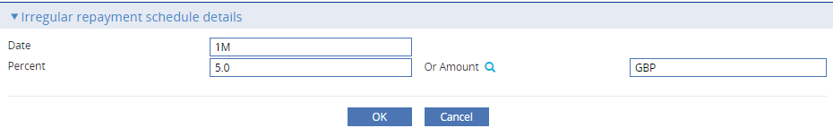

In the window that appears use the Date field to identify the date of the repayment, and then enter the amount of the repayment either as a percentage or as an actual amount using one of the two fields provided.

Press **OK** to save the repayment details.

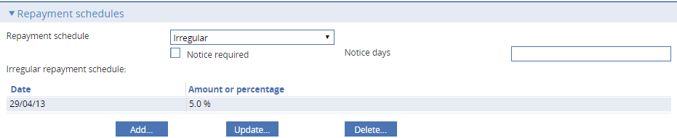

The system closes the window and displays details of the repayment in the Repayment Schedules pane. Repeat the process to define each of the remaining irregular repayments in turn. Repayments do not have to be defined in chronological order, and you can mix repayments defined as a percentage with repayments defined as an amount.

The system checks that the value of all the repayments does not exceed the amount of the financing transaction as part of the general validation of the event.

You can amend or delete entries listed in this pane in the usual way using the Update and Delete buttons.

### The Other Details Pane

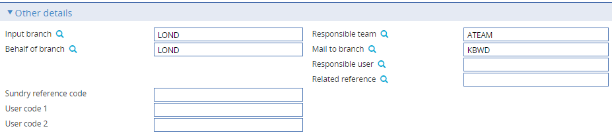

The following table explains what to enter into the fields in the Other Details pane:

| Field | What to Enter |
| --- | --- |
| Input Branch | The input branch for the transaction. The input branch is set from either:   * the accounting branch from the user’s team, or * the transaction branch for user if the user has a default transaction branch or is locked to a specific branch, or * a branch associated with the user where the user can enter transactions for several branches for a team |
| Behalf Of Branch | The behalf of branch for the transaction as entered by the user or set from the incoming SWIFT or gateway message. The behalf of branch determines the parameter sets that are to be used to generate charges, documents, postings, etc. during transaction processing. The branch can be changed to any other branch within the same main banking entity that shares the same parameter sets. |
| Sundry Ref Code /User Code 1/ User Code 2 | You may use these fields to enter values for analysis purposes. Your bank will have devised its own system for using these fields. |
| Responsible Team | The team that has overall responsibility for the master e.g., as the contact to resolve any queries or issues regarding the master and associated events. The system defaults the responsible team when creating the transaction as follows:   * Manual – set from team creating the transaction. * Gateway – set from the team specified on the incoming message (if present and valid) otherwise to the team to which the transaction is assigned through workflow allocation based on the behalf of branch. * SWIFT – set to the team to which the transaction is assigned through workflow allocation based on the behalf of branch.   It can be changed, if required, to either the team associated with the primary customer, default team for the product or the user’s current team. |
| Mail To Branch | The mail to branch can be set to any branch within the main banking entity of the behalf of branch. |
| Responsible User | A user that has responsibility for the master e.g., as the contact to resolve any queries or issues regarding the master and associated events. This can be any user assigned to the responsible team. |
| Related Reference | You can specify any other transaction to which this letter of credit is related. This may already have been done when the master record was created. You can use the browser to select from possible references to include. |

### The Charges Pane



The following table explains what to enter into the fields in the Charges pane:

|  |  |
| --- | --- |
| Field | What to Enter |
| Preferred Currency | The currency in which your bank will collect the charges. The default currency value is taken from the charge currency specified in product options. |
| Billing Level | Select whether charges for this cash letter should be billed at customer level, transaction level or product level. |
| Charges For | Select which party will pay the charges. |

### The Foreign Exchange Details Pane

The fields displayed in the FX Details pane allow you to enter one or more foreign exchange deals to support the financing transaction. See the Common Facilities User Guide – Trade Innovation for information on how to define a foreign exchange deal.

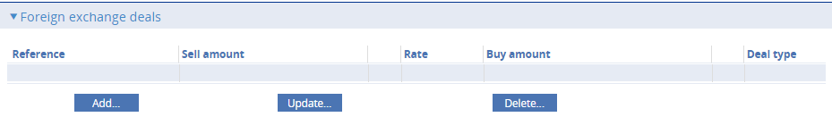

If you enter more than one foreign exchange deal, they must all be in the same currency. The system totals all foreign exchange deals entered here and uses the consolidated amount as the amount of the financing transaction in the window used to enter the amount advanced.

### The Party List Pane

The Party List pane is described in full in the Common Facilities User Guide – Trade Innovation. Additional fields are present in the Party List field for financing products that can be linked to an export credit agency facility. They allow you to link the financing transaction to an export credit agency facility.

In the Party List pane check the Link to Participation/Facility field.

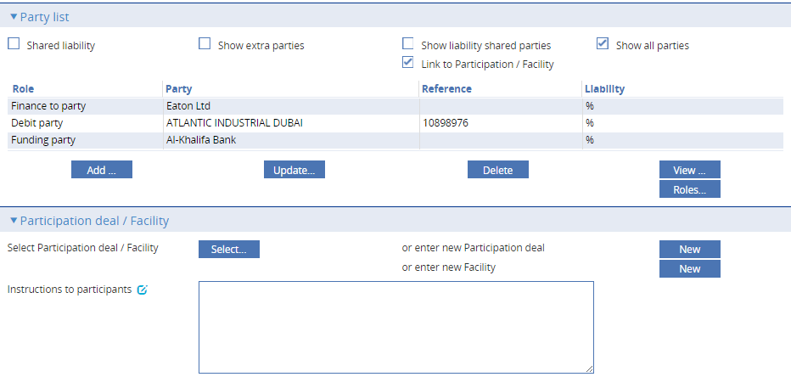

An additional pane is displayed - the Participation Deal/Facility pane. To select the export credit agency facility to which the financing transaction is to be linked press **Select**. In the window that is displayed the system lists all the export credit agency facilities set up for the principal customer (and also any participation deals the principal customer can use).

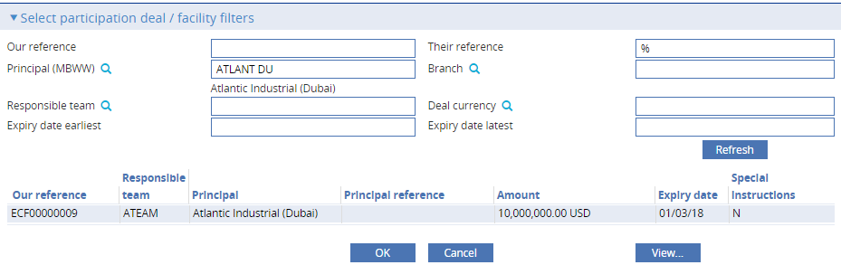

Highlight the required export credit agency facility and press **OK**.

The system closes the window, and displays details of the selected facility in the Participation Deal/Facility pane.

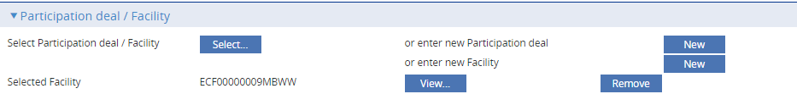

A Remove button is present in the Participation Deal/Facility pane, which you can use to remove the export credit agency facility from the transaction.

1. Once the Create event for the financing transaction has been released, you will not be able to change to a different export credit agency facility or remove the one selected.

See the Export Credit Agency Facility User Guide – Trade Innovation for more information on the how the system handles the relationship between financing transactions and export credit agency facilities.

## After You Have Completed

For independent transactions, once you have completed an Input step, the system performs any necessary review and/or authorisation steps, as required by your system. The event is then released in the usual way.

For financing transactions created as a Finance or a Finance Existing Collection event, the event itself is reviewed, as required by your system, as an event within the originating transaction. Once it has been released, it can then be processed independent of its originating transaction.

For financing transactions created from within payment events, or from within the Create event of an outward collection, once you press **Close** to save the financing transaction details you are returned to the originating event. The financing transaction details are treated as a subsidiary event of the event in which they were entered. They are reviewed (as required) and released as part of that event. If you need to amend the financing transaction details you can do so from within the event in the usual way, as described in the appropriate User Guide.

See the Common Facilities User Guide – Trade Innovation for more information about subsidiary events.

However, the financing transaction is created, once the event in which its details were entered has been released the system creates a new master record for it. This can be opened from within the Open Master window and worked on independently.

1. You cannot work independently on a financing transaction created for a clean bankers acceptance. These are only updated from the clean bankers acceptance master. See the Clean bankers Acceptances User Guide – Trade Innovation for further details.

Financing transactions created as part of a payment event or a Create event for outward collection orders can also be paid from within payment events initiated in the originating transaction.

For financing transactions initiated from within another transaction, the Create or Pay events will show a status of 'Subsidiary', plus the master reference of the originating transaction.

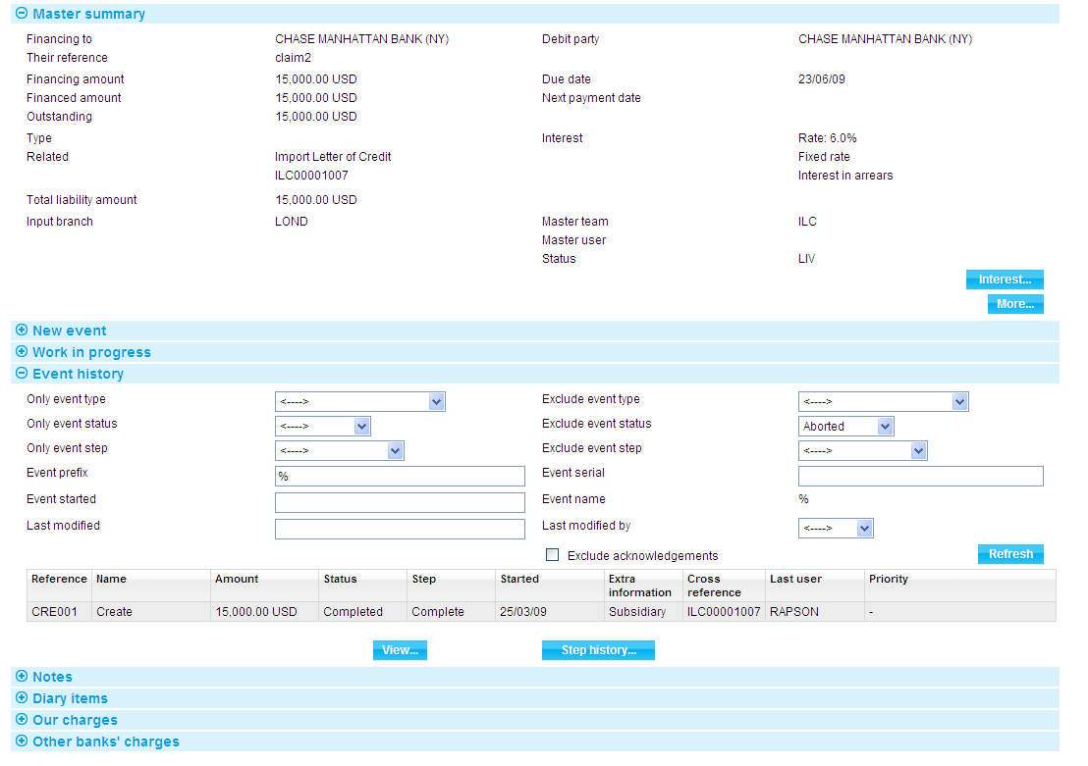

The Master Summary window for the associated transaction will include a Cross Ref button. When you press it, the window displayed will include details of the associated financing transaction.

## The Master Summary Window for a Financing Transaction

Once you have created a financing transaction the Master Summary window shows basic details of the finance standalone transaction.

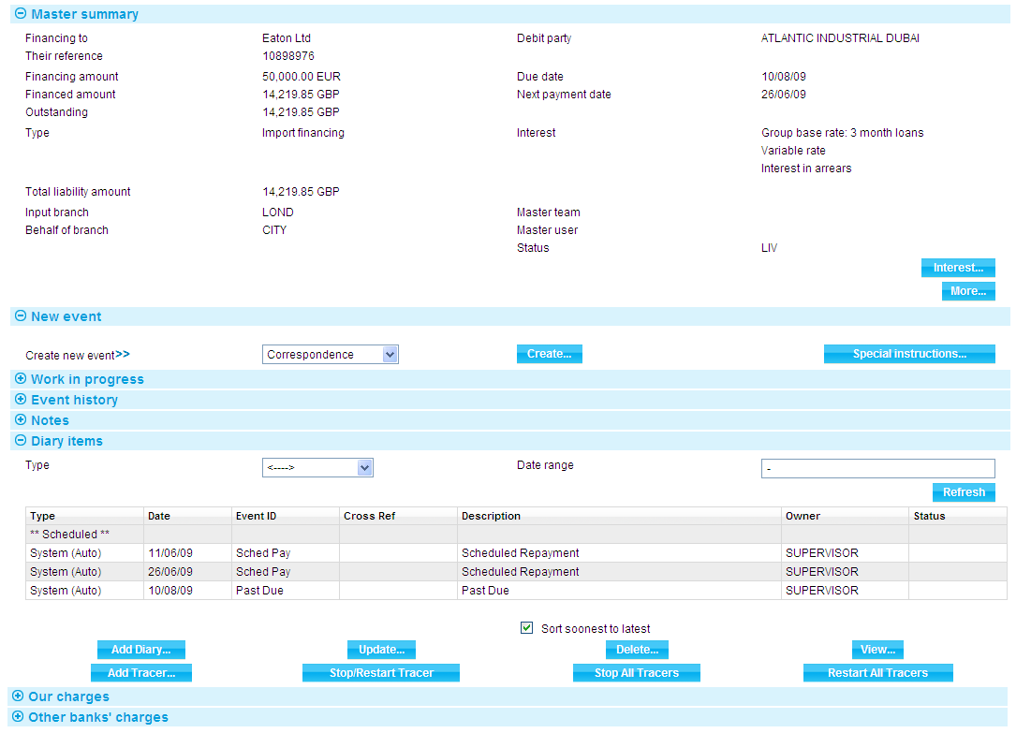

Once you create a financing transaction, the Master Summary window shows basic details of the Finance Supply Chain Finance transaction. The window contains the details of finance transaction along with Supply Chain Finance details.

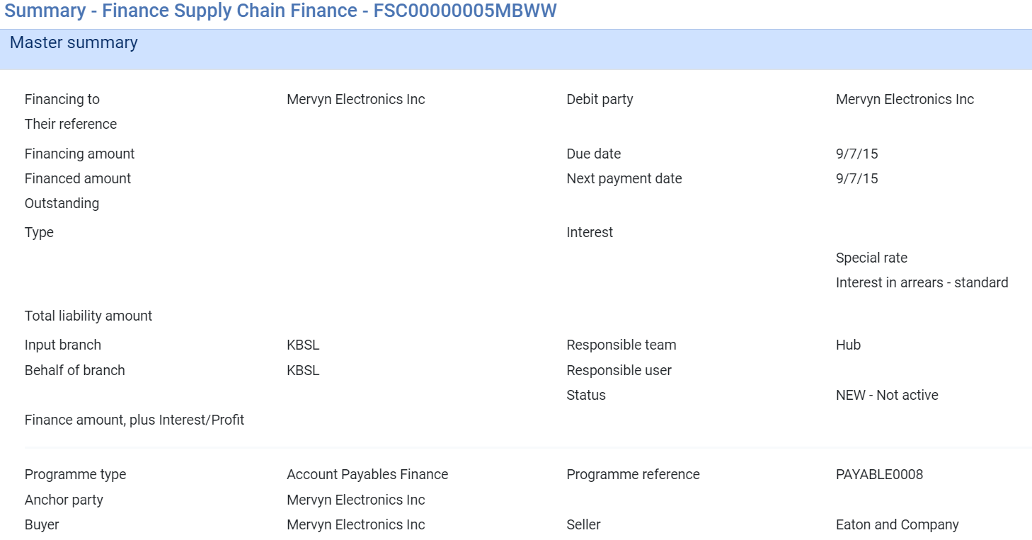

For more information on how the various panes and buttons in this window work see the Common Facilities User Guide – Trade Innovation.

If the transaction involves cost-of-funds interest, then the finance interest rate for financing transactions may include or exclude cost-of-funds, depending on the value of the system option FinanceInterestExcludesCOF.

Once a financing transaction has been completed, the system provides a facility to allow you to calculate and display the effects of a principal repayment made on a particular date (see page 41).

For participated loans, a Share button is available (see page 40).

If the financing transaction is linked to an export credit agency facility, the Related Masters link in the Master Summary window for the financing transaction shows details of the export credit agency facility to which it is linked.

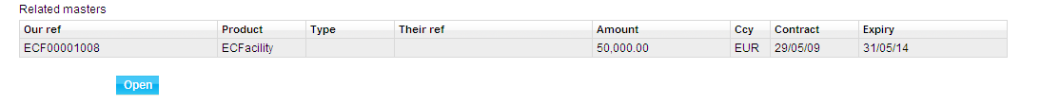

The Related Masters link in the Master Summary window for the export credit agency facility shows details of the financing transactions to which it is linked.

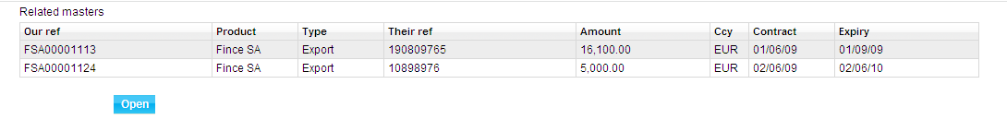

### Calculating the Effect of Principal Repayments

In the Master Summary window for the finance transaction press **Interest**.

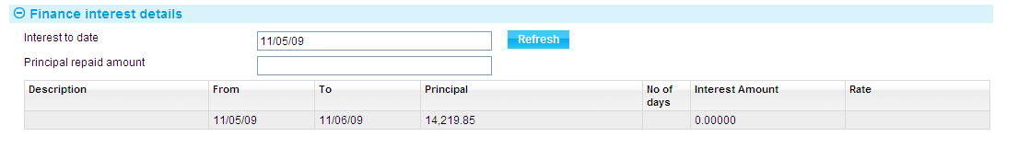

Enter the proposed date of the repayment into the Interest to Date field, and the proposed repayment amount into the Principal Repaid Amount field, then press **Refresh**. The system calculates and displays the effect of the principal repayment.

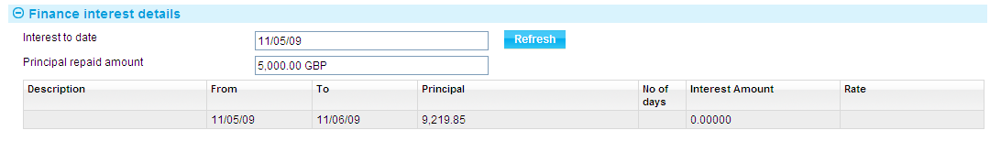

The window shows the interest rates applied to the principal amount during different periods of the term, and the resulting interest due in each period of the loan, taking into account the proposed principal repayment.

### Additional Information for Participated Loans

If you select a line and press **Share**, the system displays a breakdown of the interest that is to be paid to each participant, and the amount that remains for your bank.

If more than one repayment period is shown, the Show All Periods field is displayed. By default this is blank, and only details of the current repayment period are shown. If you check this box, details of all repayment periods are shown.

# Scheduled Repayments

When you first enter details of an interest-bearing financing transaction, the system permits you to define schedules determining the repayment of interest and principal amounts. You can set up separate schedules for interest and for principal repayments. When the financing transaction is released, the system uses these schedules to create diary entries to effect repayments as they fall due. For discounted bills, the system creates a single entry in the diary for the final repayment.

For more information on setting up the schedules governing when repayments are generated see Chapter 2.

When a repayment falls due as part of overnight processing the system processes it in the following way.

If you have defined repayment to occur automatically - by setting the Auto Repay flag - the system automatically generates the necessary postings using funds from the account designated for repayment.

Provided there are sufficient funds in the account the event is released without requiring manual intervention from you. If there are insufficient funds in the designated account, or if you have the system's departmental limits module implement and an overline condition is reported, the system places a Scheduled Repayment event in the Work in Progress pane for the financing transaction, and you can either authorise or reject it, as appropriate. If your system is configured so that automatic repayments rejected due to lack of funds are automatically removed from the system, the system also generates a Scheduled Repayment Reject diary action to remove the Scheduled Repayment event the appropriate number of days after it was generated (unless it has been authorised by then).

If you have not defined repayments to occur automatically, the system places a Scheduled Repayment event in the Work in Progress pane for the financing transaction for you to authorise or reject.

If the AllowProjectionOnlyPostings system option is set to Yes, projection postings are also generated for the next anticipated repayment, and reversed when that repayment is made.

For interest-bearing transactions, once the Scheduled Repayment event has been released, the system generates a diary event for the next repayment of interest or principal until the term of the transaction has been reached.

If two repayments - one for interest, one for principal - fall due on the same day, the system generates a single Scheduled Repayment event to cover both amounts.

Where customer markup or cost of funds interest capitalisation is set for this transaction, the relevant tick-box is presented as read-only on the scheduled repayment event screen. Capitalisation would happen if the scheduled repayment is not for the full amount or was rejected. Authorised final repayments will have no interest to capitalise.

If interest or cost of funds is capitalised, the interest amount is added to the principal. This can be scheduled at the same time as principal repayments.

A repayment notice (see Chapter 9) can also be scheduled to occur a defined number of days before the repayment date. This can be used to inform the party making repayment of the amount due from them.

If the financing transaction is participated and the participation deal is revolving, repayment may result in a Drawdown/Revolve Commit Amt event being created as a subsidiary event, to increase the commitment amount available on the deal.

## If a Scheduled Repayment Event Fails

The system option DeferChargesAtRejectRepay controls how charges are handled if a Scheduled Repayment event fails, either during automatic overnight processing or as a result of a manual rejection.

If this system option is not set or is set to No, charges are taken in the same was as if the event had completed successfully. If the system option is set to Yes, the charges will instead be deferred.

1. If you have not defined schedules for repayment, then the financing transaction must be repaid either manually from within the financing transaction, or via a payment event in the originating transaction. For instructions on manual repayments see Chapter 4, and for instructions on repayment via a payment event in the originating transaction see Chapter 5.

This chapter does not apply to financing transactions for clean bankers’ acceptances. Repayments for these transactions are controlled from within the clean bankers’ acceptance master.

## Manually Completing a Scheduled Repayment

When you open a Scheduled Repayment event at an Input step the system permits you to enter a reference for the repayment into the Reference field, and to amend which party is to make the repayment using the Repayment Payer field.

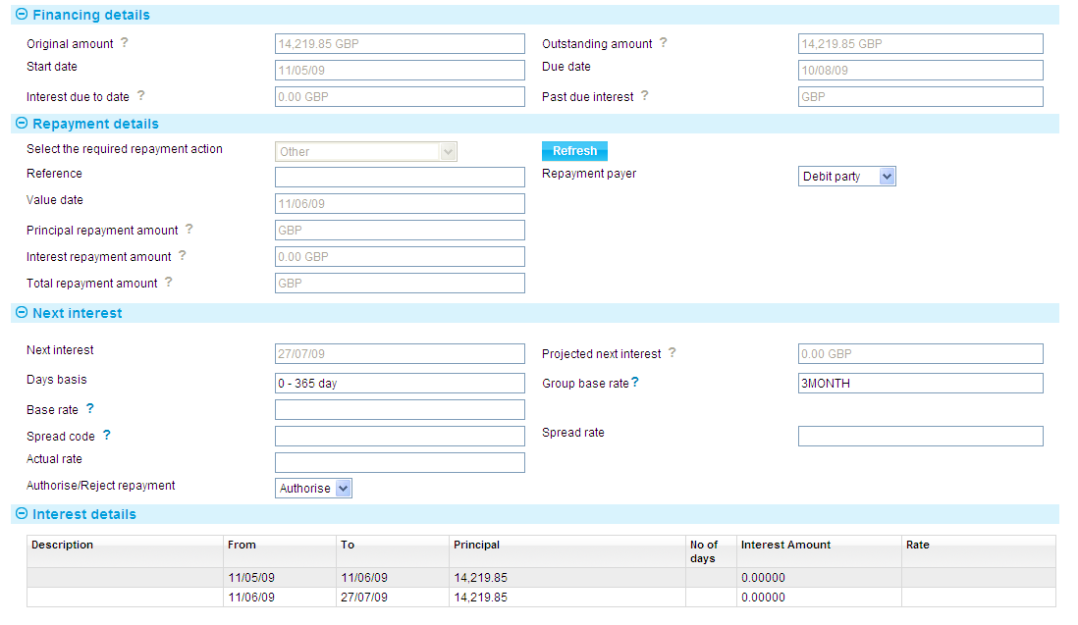

The Schedule Repayment event for Finance Supply Chain Finance, the screen has an additional pane called Originator’s Details Pane (see page 19)



Use the Authorize/Reject Repayment field to either complete the payment or to reject it. The diary event for the next repayment is generated in either case.

Processing differs, depending on whether the repayment event is for an interest-bearing transaction or a discounted bill.

### For Interest-bearing Transactions

For principal repayments only, the Next Interest Details pane is not present in the window displayed when you open a Scheduled Repayment event for a financing transaction with interest in arrears or in advance.



The Financing Details pane shows the status of the advance, including the original finance amount, the amount outstanding, the term of the advance, and the interest due to date. If you press **View**, the system displays the Finance Interest Details window, which shows how interest has been calculated on the transaction for the current interest period.

The Repayment Details pane shows details of the repayment required. For a principal repayment, it will show the value date of the repayment and the principal amount to be repaid. For an interest repayment, it will show the value date of the repayment and the interest amount due.

The Select the Required Payment Action field in the Repayment Details pane is set automatically depending on whether the repayment is of principal, interest, or both.

The Next Interest pane shows, for interest repayments, the date the next interest repayment is due and the projected next interest amount.

For financing transactions involving interest in arrears, the interest due is the interest for the current period, from the last repayment date to the current processing date.

For financing transactions involving interest in advance, the interest due is for the next period, from the value date until the next interest date. Any changes you make to the interest schedule therefore affect the figure in the Projected Next interest field for interest in arrears, and the figure in the Interest Amount and Total repayment Amount fields for interest in advance.

### Customer Interest Capitalisation

Where interest due from the customer is capitalised, the repayment event indicates interest is capitalised in the Interest due to date description text, also available for customer statements. The interest amount is added to the principal.

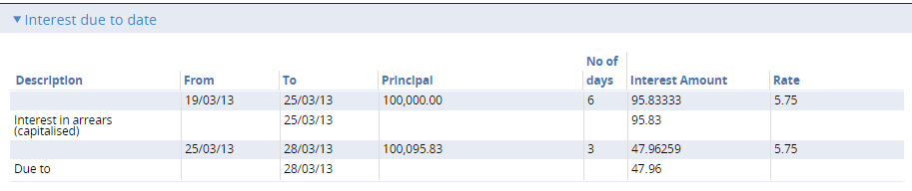

### For Discounted Bills

For discounted bills, when you open the Scheduled Repayment event the Financing Details pane shows details of the advance, including the original finance amount, the amount outstanding and its currency, the term of the advance, and the due date.

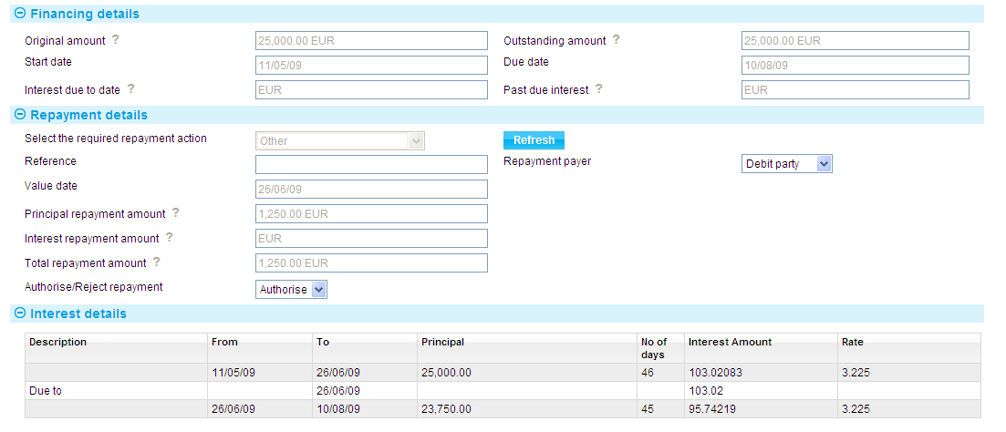

The Repayment Details pane shows the value date of the repayment and the principal amount to be repaid.

### Cost of Funds Interest and Scheduled Repayment Events

If the financing transaction is linked to an export credit agency facility, additional cost of funds panes are displayed during the Scheduled Repayment event.

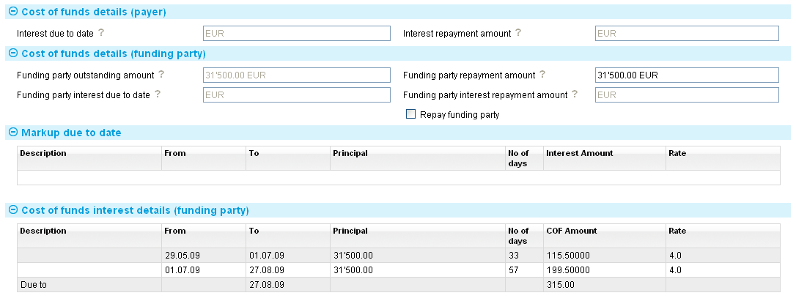

These panes display details of the values used in calculating cost-of-funds interest for the export credit agency. (Whether or not you can amend these depends on the security capability UpdateFundingPartyRate.)

The following table explains what the fields in these panes show:

|  |  |
| --- | --- |
| Field | What to Enter |
| Interest Due to Date | The interest due to date from the customer, up to the date of the Scheduled Repayment event. |
| Interest Repayment Amount | The interest repayment amount due from the customer in this Scheduled Repayment event. |
| Funding Party Outstanding Amount | The principal amount of funding yet to be repaid or returned to the funding party. |
| Funding Party Repayment Amount | The amount to be repaid to the funding party in this Repay event. |
| Funding Party Interest Due To Date | The amount of interest due to the funding party in this Repay event. |
| Funding Party Interest Repayment Amount | The amount of interest to be paid to the funding party in this Repay event. |
| Repay Funding Party | This field is displayed if the Repay event involves a repayment of interest or principal. Check the flag if a repayment is to be made to the funding party. |

The Markup Due To Date pane shows:

* The start and end date of the period for which markup interest for the customer is calculated
* The number of days in that period
* The principal amount on which markup interest for the customer is calculated, and the actual markup interest for the customer in the financing transaction currency
* The rate at which markup interest for the customer is calculated

The Cost of Funds Interest Details (Funding Party) pane shows information on the cost of funds due to the funding party. The Due To field shows the date the cost of funds is due to be paid.

## Cost of Funds and Markup Interest Capitalisation

If the financing transaction is linked to an export credit agency facility additional panes are displayed during the Repay event. Cost of funds interest is usually capitalised in conjunction with the markup interest. The repayment event indicates interest is capitalised in the Interest due to date description text, also available for customer statements.

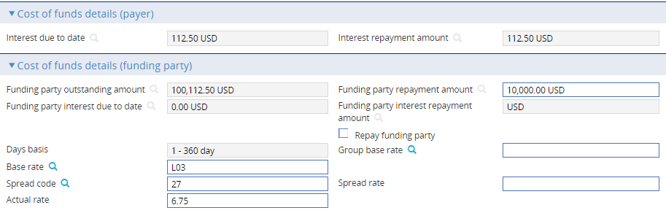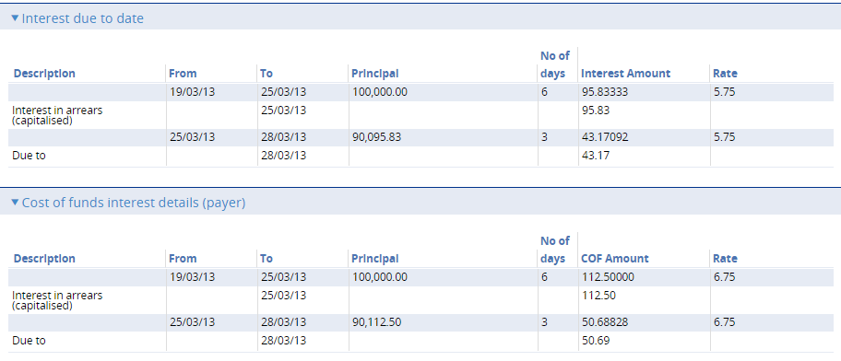

# Manual Repayments

The system permits you to make manual repayments against a financing transaction at any point after it has been released.

Manual repayments use the Repay event, and can be processed in one of the following ways:

* Final payments, involving full repayment of interest and principal, after which no further actions can be carried out against the financing transaction
* Principal plus interest to date, for which the system calculates the amount of interest to be paid. You then enter the amount to be repaid in addition to the interest amount
* Interest to date, then principal, which involves entering the total amount received. The system calculates the interest due to date and apportions the appropriate amount to interest repayment. It then calculates how much is left to pay off the principal
* Repayment of any portion of the interest or principal amounts

For discounted bills, only the first type of repayment is permitted.

In addition, you can use a manual repayment event to transfer either a part or the whole of the outstanding principal and interest amounts of an existing financing transaction to a new financing transaction into a currency that differs from the currency of the original loan. See Chapter 7 for instructions.

If you enter a manual repayment against a financing transaction with scheduled repayments, the system takes the manual repayment into account when processing the next Scheduled Repayment event (see Chapter 3).

Where customer markup or cost of funds interest capitalisation is set for this transaction:

* the relevant tick-box is input capable on the manual repayment event screen to allow optional capitalisation of any unpaid amount, defaulted as unticked. Under the repayment action ‘Final Payment’ interest capitalisation will not occur. The capitalisation tick-box is defaulted as unticked as interest capitalisation would apply for all scheduled repayments (where not fully paid), providing outstanding interest capitalisation for each period. Where a mid-period ad-hoc payment is made (using a manual repayment event), this should not capitalise be default, as it would cause any remainder to capitalise additionally mid-period.

After past due, outstanding amounts can be repaid through manual repayments. These payments can optionally be set to capitalise. A manual repayment of zero amount can be used to capitalise the full balance.

If you enter a manual repayment against a financing transaction which is subsequently repaid in full or in part during a payment event against the originating transaction, the amount of the manual repayment will be deducted from the amount outstanding.

If the financing transaction is participated, and the participation deal is revolving, repayment may result in a Drawdown/Revolve Commit Amt being created as a subsidiary event, to increase the commitment amount available on the deal.

If the AllowProjectionOnlyPostings system option is set to Yes, you can set up projection-only postings for the anticipated maturity date. Those projections will be reversed automatically at maturity, or when a repayment of principal changes the maturity date.

The system issues warning messages if you attempt to create a manual repayment for a financing transaction for which there is an unreleased amendment event or an event involving a repayment in progress.

1. This chapter explains how to enter manual repayments against a financing transaction. For instructions on automatic scheduled repayments see Chapter 3, and for instructions on repayment via a payment event in the originating transaction see Chapter 5.

It does not apply to financing transactions for clean bankers acceptances. Repayments for these transactions are controlled from within the clean bankers acceptance master.

## Cost of Funds Interest and Manual Repayments

If the financing transaction is linked to an export credit agency facility additional panes are displayed during the Repay event.

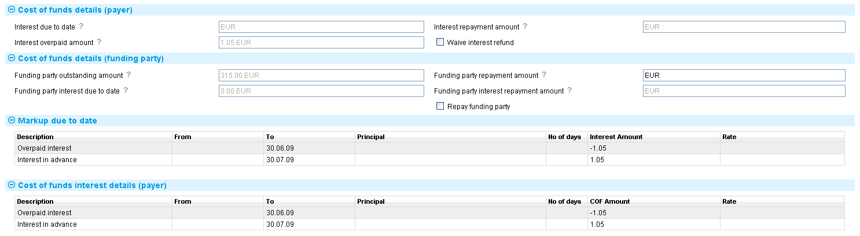

These panes display details of the cost of funds for the interest period in question, including values used in calculating cost-of-funds interest for the export credit agency and markup interest for the customer. Whether or not you can amend these depends on the security capability UpdateFundingPartyRate.

|  |  |
| --- | --- |
| Field | What to Enter |
| Interest Due to Date | The interest due to date from the payer, up to the date of the Repay event. |
| Interest Repayment Amount | The interest repayment amount due from the payer in this Repay event. |
| Funding Party Outstanding Amount | The principal amount of funding yet to be repaid or returned to the funding party. |
| Funding Party Repayment Amount | The amount to be repaid to the funding party in this Repay event. |
| Interest Overpayment Amount | Any amount of interest overpaid. |
| Waive Interest Refund | Check this field if any interest overpaid is not to be refunded. |
| Funding Party Interest Due To Date | The amount of interest due to the funding party in this Repay event. |
| Funding Party Interest Repayment Amount | The amount of interest to be paid to the funding party in this Repay event. |
| Repay Funding Party | This field is displayed if the Repay event involves a repayment of interest or principal. Check the flag if a repayment is to be made to the funding party. |

The Markup Due To Date pane shows:

* The start and end date of the period for which markup interest for the customer is calculated
* The number of days in that period
* The principal amount on which markup interest for the customer is calculated, and the actual markup interest for the customer in the financing transaction currency
* The rate at which markup interest for the customer is calculated

The Cost of Funds Interest Details (Payer) pane shows information on the cost of funds due from the payer.

## Making a Manual Repayment

To enter a manual repayment, in the Master Summary window select 'Repay' from the Create New Event drop-down list and click **Create**. The system opens the event at either a Log step or Input step. Depending on how your system is configured, panes and fields available in log steps can be tailored for each data capture step. See the *SDK - Screen Tailoring Guide – Trade Innovation* for details.

The following is the screen for entering manual repayment details for finance standalone

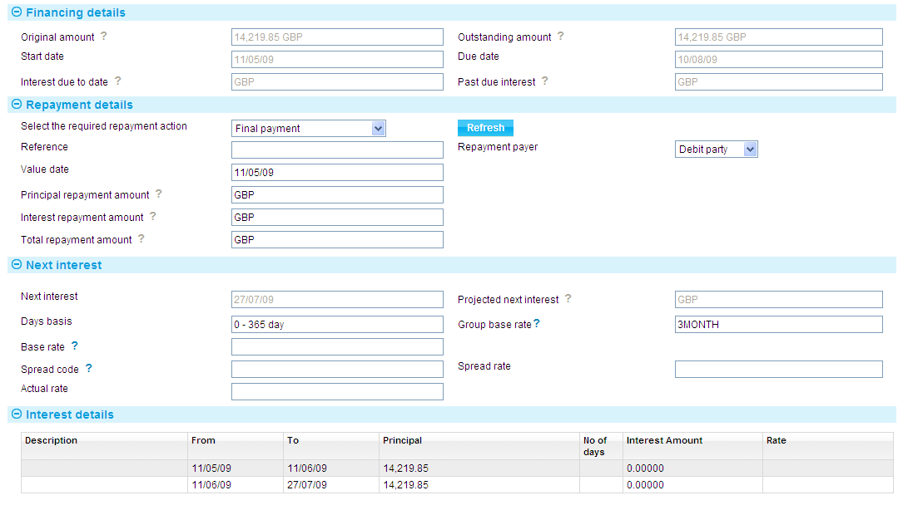

The following is the screen to enter the manual repayments details for Finance Supply Chain Finance

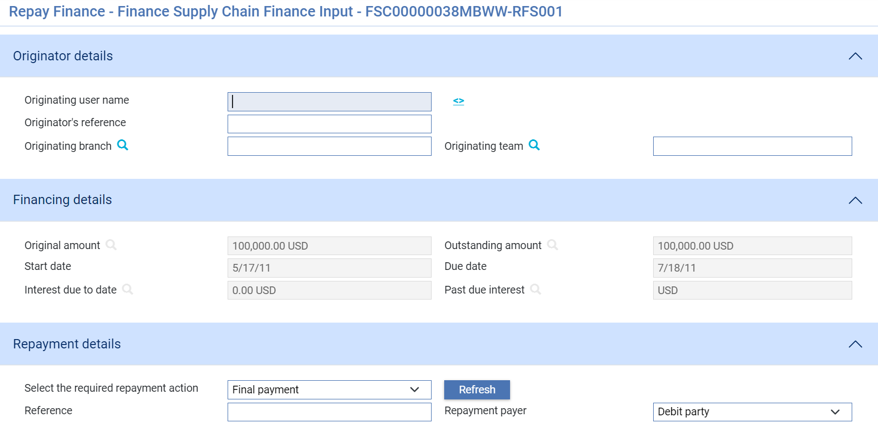

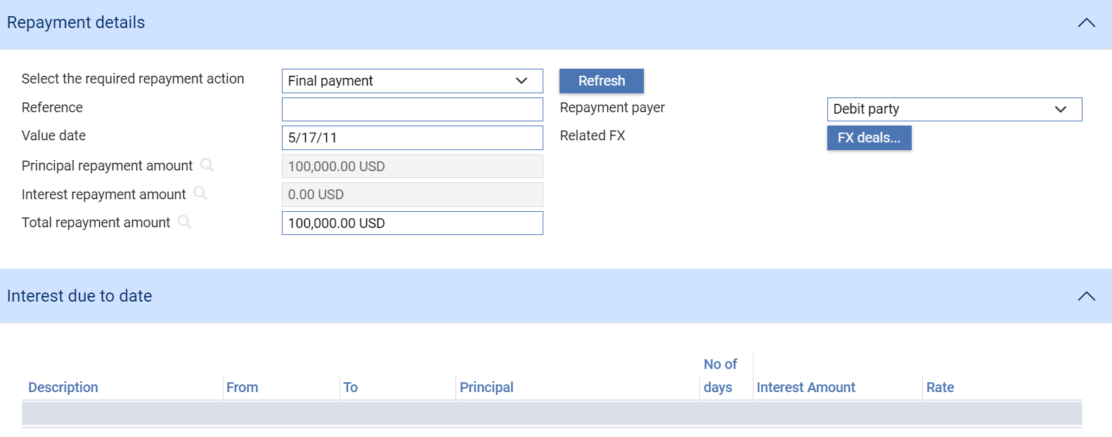

1. The system issues warning messages if you attempt to create a manual repayment for a financing transaction for which there is an unreleased amendment event or an event involving a repayment in progress.

The Originator’s Details pane shows the details of the bank user who is creating the transaction in the system (see page 19)

The Financing Details pane shows details of the advance, including the original finance amount, the amount outstanding, the term of the advance, the interest due to date and the past due interest. If you press View, the system displays the Finance Interest Details window, which shows how interest has been calculated on the transaction.

The Next Interest Details pane shows the date the next interest repayment is due and the projected next interest amount. The Interest Details pane shows details of interest payments to date.

The fields in the Repayment Details pane allow you to enter details of the repayment. Except for the Reference field, which allows you to enter a reference for the repayment, these fields change depending on what type of repayment you are making.

Select from one of the following values in the Select the Required Repayment Action field to indicate the type of repayment you want to make:

* Final repayment for an interest-bearing transaction (see page 52)
* Final repayment for a discounted bill (see page 53)
* Principal plus interest to date (see page 53)
* Interest to date, then principal (see page 55)
* Other - any portion of the interest (see page 59)

Last payment then transfer - see Chapter 7 for instructions on using this option.

For a discounted bill a manual repayment event can only be used to make a final payment, repaying the amount in full.

## Repayment via gateway

A repayment may be initiated from an interface. This triggers a new Repay event which is processed in the same way as when created manually. Repay events via gateway are not permitted in Trade Innovation under the following circumstances:

* The Repay event is already in progress
* The Repay event has already been finalised

If a Repay event is created manually or via gateway, some fields may be automatically determined depending on the Repayment action such as Principal repayment amount, Interest repayment amount and Total repayment amount in a Final Payment. The field characteristics (i.e. editable, system-calculated) are the same when created manually or via gateway.

Values from the gateway that do not match those computed by the system are displayed in Action items requiring review.

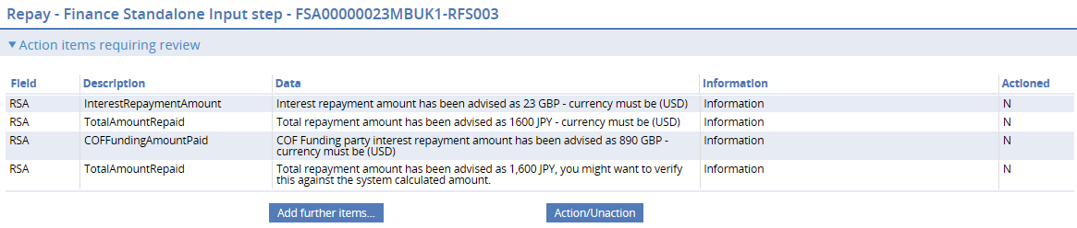

The determined characteristics of each field and the decision made by the system upon receipt of the repayment instruction via gateway are shown in the tables under each Repayment Action explained in the following sections.

### Final Payment (for Interest-bearing Transactions)

In the Select the Required Payment Action field select 'Final Payment' and press **Refresh**.

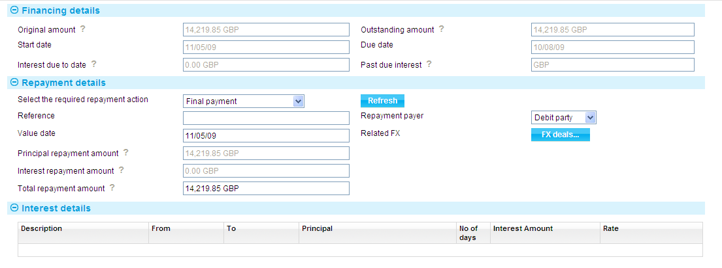

The system displays the value date of the payment in the Value Date field. For independent financing transactions the system uses today's date as the default, and for other financing transactions the value date of the originating event. You can overtype this date, if required.

The system displays the outstanding principal and interest in the Principal Amount and Interest Amount fields respectively. The Total Repayment Amount field shows the sum of these two figures, which is the amount needed to fully repay the advance.

For financing transactions with interest in advance, a principal repayment before the due date, or before the next interest period, will result in an overpayment of interest. In such a case the system will display the refund due in the Interest Overpaid Amount field.

For financing transactions where customer interest or cost of funds interest is capitalised, in the final period these are not capitalised.

You can change the value in the Total Repayment Amount field to reflect the actual amount received - the system will calculate any differences in the following way:

* If the amount entered is more than the required amount to fully settle the transaction, an overpayment of principal will be shown. This amount will then be paid to the relevant party, according to the postings set up by your bank. For example, for an export financing transaction, the overpayment will be paid to the beneficiary
* If the amount entered is less than the required amount, the system will calculate any underpayment of principal and interest for recovery from the relevant party, according to the postings set up by your bank

For repayments made in a currency other than the transaction currency, you can use the FX Deal button to enter a foreign exchange deal to provide funds in the required currency.

If required, use the Repayment Payer field to amend which party is making the repayment.

### Final Repayment (For a Discounted Bill)

For a discounted bill the only action possible within a manual repayment event is to make repayment in full.

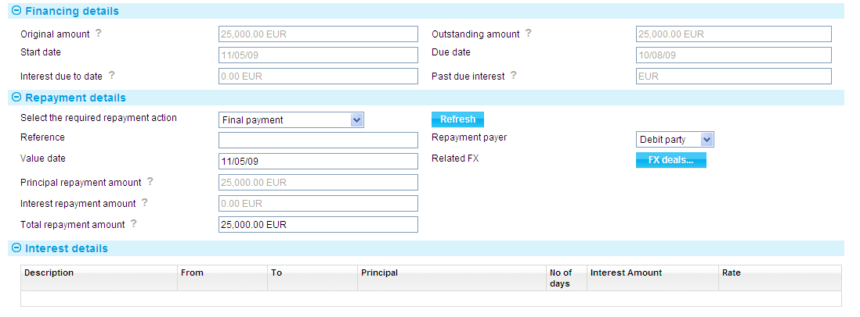

The Financing Details pane shows details of the advance, including the original finance amount, the amount outstanding, and the term of the advance. The Interest Details pane shows how discount has been calculated on the transaction.

In the Repayment Details pane the system displays the amount due in the Total Repayment Amount field and the value date of the payment. For independent financing transactions the system uses today's date as the default, and for other financing transactions the value date of the originating event. You can overtype this date, if required.

If required, use the Repayment Payer field to amend which party is making the repayment.

1. For discounted bills there is no refund of overpayments, nor any past due interest processing.

Field characteristics and system behaviour when Repay event is created via gateway with Repayment Action of Final payment.

| Field | Present | Valid | Decision | Allow to Edit |
| --- | --- | --- | --- | --- |
| Reference | Y/N | - | Add to field | Y |
| Value date | Y | Y | Add to field | Y |
| Y | N | Action item requiring review |
| N | - | System pre-filled |
| Principal repayment amount | Y/N | Y | System pre-filled | N |
| Y | N | * System pre-filled * Action item requiring review |
| Interest repayment amount | Y/N | Y | System pre-filled | N |
| Y | N | * System pre-filled * Action item requiring review |
| Total repayment amount | Y | Y | Add to field | Y |
| Y | N | *Principal and Interest repayment amount will adjust resulting to an additional field, Principal underpaid/overpaid amount.* |
| N | - | System pre-filled |
| Repayment payer | Y | Y | Display selection | Y |
| Y | N | Action item requiring review |
| N | - | System default |
| Related FX | Y/N | Y/N | Action item requiring review | Y |

Values from the gateway for other fields relating to interest (i.e. Next interest, Days basis, Base rate, Spread rate) are found in the Action items requiring review.

### Principal Plus Interest to Date

In the Select the Required Payment Action field select 'Principal Plus Interest To Date' and press **Refresh**.

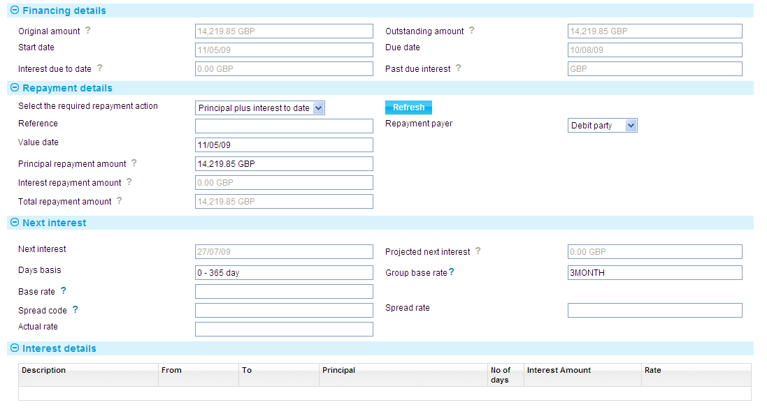

The value date of the payment is shown in the Value Date field.

For independent financing transactions the system uses today's date as the default, and for other financing transactions the value date of the originating event. You can overtype this date, if required.

The system uses the value date to calculate the interest due to date, and displays this in the Interest Amount field.

Enter the principal amount to be repaid into the Principal Repayment Amount field. The system calculates the total repayment due, both principal and interest, and displays the figure in the Total Repayment Amount field.

If required, use the Repayment Payer field to amend which party is making the repayment.

Field characteristics and system behaviour when Repay event is created via gateway with Repayment Action of Principal plus interest to date.

|  |  |  |  |  |
| --- | --- | --- | --- | --- |
| Field | Present | Valid | Decision | Allow to Edit |
| Reference | Y/N | - | Add to field | Y |
| Value date | Y | Y | Add to field | Y |
| Y | N | Action item requiring review |
| N | - | System pre-filled |
| Principal repayment amount | Y | Y/N | Add to field | Y |
| N | - | System default |
| Interest repayment amount | Y | Y/N | Action item requiring review | N |
| N | - | System default |
| Total repayment amount | Y | Y/N | Action item requiring review | N |
| N | - | System default |
| Repayment payer | Y | Y | Display selection | Y |
| Y | N | Action item requiring review |
| N | - | System default |

Values from the gateway for other fields relating to interest (i.e. Next interest, Days basis, Base rate, Spread rate) are found in the Action items requiring review.

### Interest to Date, then Principal

In the Select the Required Payment Action field select 'Interest To Date, then Principal' and press **Refresh**.

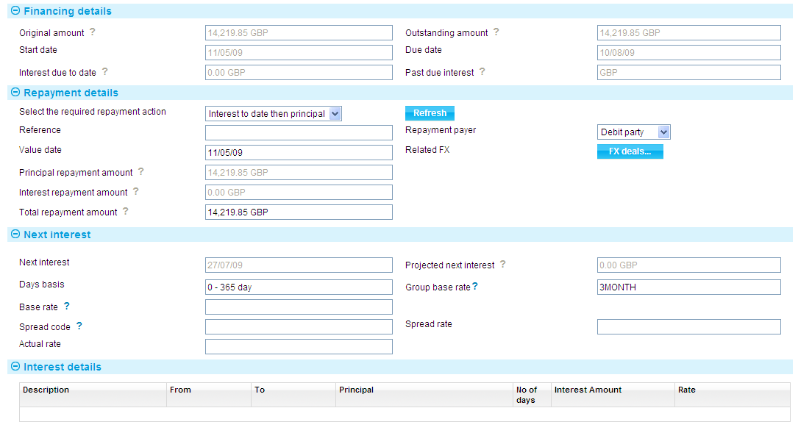

For repayments involving interest to date, then principal, the system displays the value date of the payment in the Value Date field. For independent financing transactions the system uses today's date as the default, and for other financing transactions the value date of the originating event. You can overtype this date, if required.

The system uses the value date to calculate the interest due to date, and displays this in both the Interest Repayment Amount and the Total Repayment Amount field. Overtype this figure, entering the amount of the repayment. The system deducts the interest due from the amount entered, and displays the remainder in the Principal Repayment Amount field. this is the amount that will be used to reduce the principal.

For repayments made in a currency other than the transaction currency, you can use the FX Deal button to enter a foreign exchange deal to provide funds in the required currency. See the Common Facilities User Guide – Trade Innovation for instructions.

If required, use the Repayment Payer field to amend which party is making the repayment.

Field characteristics and system behaviour when Repay event is created via gateway with Repayment Action of Interest to date then principal.

|  |  |  |  |  |
| --- | --- | --- | --- | --- |
| Field | Present | Valid | Decision | Allow to Edit |
| Reference | Y/N | - | Add to field | Y |
| Value date | Y | Y | Add to field | Y |
| Y | N | Action item requiring review |
| N | - | System pre-filled |
| Principal repayment amount | Y | Y/N | Action item requiring review | N |
| N | - | System default |
| Interest repayment amount | Y | Y/N | Action item requiring review | N |
| N | - | System default |
| Total repayment amount | Y | Y | Add to field | Y |
| Y | N | Action item requiring review |
| N | - | System default |
| Repayment payer | Y | Y | Display selection | Y |
| Y | N | Action item requiring review |
| N | - | System default |
| Related FX | Y/N | Y/N | Action item requiring review | Y |

Values from the gateway for other fields relating to interest (i.e. Next interest, Days basis, Base rate, Spread rate) are found in the Action items requiring review.

### Other

The 'Other' option permits you to repay any portion of the interest or principal amounts. In the Select the Required Payment Action field select 'Other' and press **Refresh**.

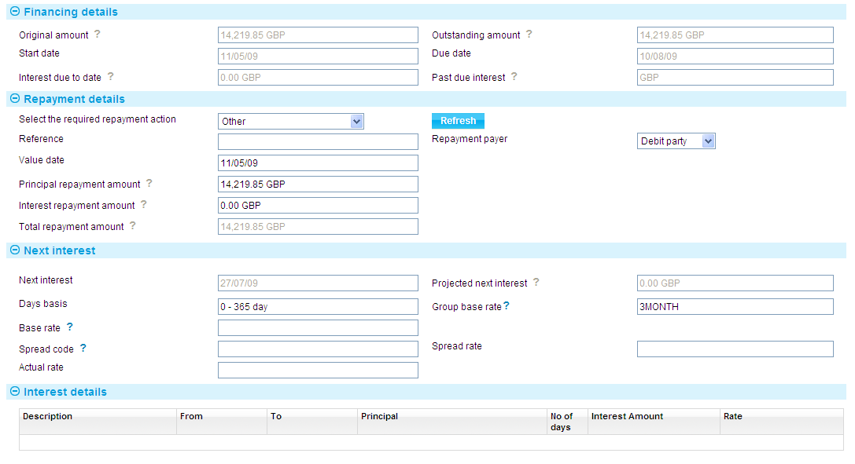

The system displays the value date of the payment in the Value Date field. For independent financing transactions the system uses today's date as the default, and for other financing transactions the value date of the originating event. You can overtype this date, if required.

The system uses the value date to calculate the interest due to date and displays this in the Interest Amount field and the Total Repayment Amount field.

The Principal Repayment Amount field and the Interest Repayment Amount field are both enabled to allow you to enter the principal and interest amounts to be repaid. You can overtype the figure in the Interest Amount field. The system calculates the total amount of the repayment and displays it in the Total Repayment Amount field.

For financing transactions with interest in advance, if the repayment is before the due date the system calculates interest overpayment and displays the amount in the Interest Overpaid field. You may waive the refund by checking the Waive Interest Refund box.

For repayments made in a currency other than the transaction currency, you can use the FX Deal button to enter a foreign exchange deal to provide funds in the required currency.

If required, use the Repayment Payer field to amend which party is making the repayment.

Field characteristics and system behaviour when Repay event is created via gateway with Repayment Action of Other.

| Field | Present | Valid | Decision | Allow to Edit |
| --- | --- | --- | --- | --- |
| Reference | Y/N | Y/N | Add to field | Y |
| Value date | Y | Y | Add to field | Y |
| Y | N | Action item requiring review |
| N | - | System pre-filled |
| Principal repayment amount | Y | Y | Add to field | Y |
| Y | N | Action item requiring review |
| N | - | System default |
| Interest repayment amount | Y | Y | Add to field | Y |
| Y | N | *Interest repayment amount is validated against the ‘Interest due to date’ which may bring out additional field, Interest underpaid/overpaid amount.* |
| N | - | System pre-filled |
| Total repayment amount | Y/N | - | System default | N |
| Repayment payer | Y | Y | Display selection | Y |
| Y | N | Action item requiring review |
| N | - | System default |

Values from the gateway for other fields relating to interest (i.e. Next interest, Days basis, Base rate, Spread rate) are found in the Action items requiring review.

# Repayment via the Originating Transaction

The system allows for repayment of a financing transaction for an import or export letter of credit, guarantee or standby letter of credit as part of an Outstanding Claim or Outstanding Presentation event.

## Financing Transactions during a Payment Event

During a Claim Received or Documents Presented event, the system permits you to enter details of a financing transaction that is to be paid at maturity. During a subsequent Outstanding Claim or Outstanding Presentation event for the originating transaction you can allocate funds to the associated financing transaction.

For payment events for which the payment action is 'Pay at maturity', once the event is released the system creates a diary event which will generate an Outstanding Presentation event in the Work in Progress pane when the maturity date is reached.

If the financing transaction is being participated and the participation deal is revolving, repayment may result in a Drawdown/Revolve Commit Amount event being created as a subsidiary amount, to increase the commitment amount available on the deal.

During payment events, you can also make a repayment against a financing loan. For collection orders you can also repay the financing of discounted acceptances during a Payment event.

The system permits you to make a loan repayment with various payment actions. However, your bank can configure the system so that loan repayment is permitted only where the payment action involves a payment. (This is done by defining error messages to prevent loan repayment where the payment action does not involve the receipt of funds. See the System Tailoring User Guide – Trade Innovation for instructions on defining error messages.)

## Repaying Financing at Payment Level for Letters of Credit, Standbys and Guarantees

This section explains how to repay a financing transaction held at payment level, rather than against the master record.

For full instructions on the Outstanding Claim or Outstanding Presentation events see the product-specific the system user guides.

When you open the Outstanding Claim or Outstanding Presentation event the Associated Payment Details pane displays a Finance line. This shows the financing transaction amount and currency, and the term of the advance.

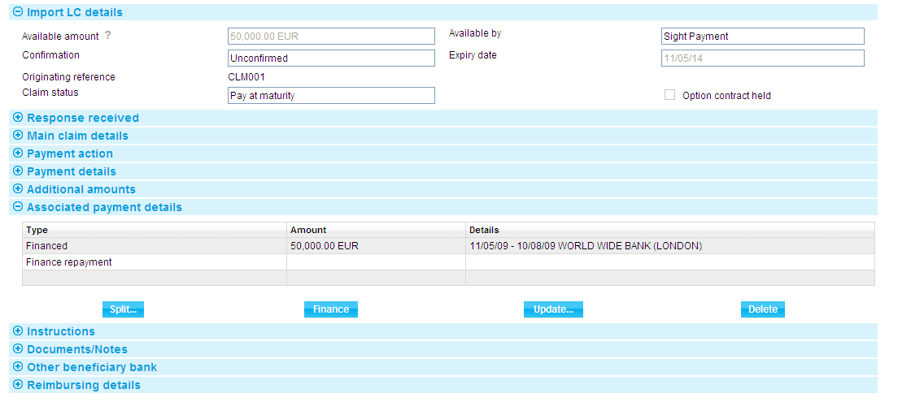

Highlight the Finance Repayment line and press **Update**. The system opens a Repay event, which you can use to repay the loan in the usual way (see Chapter 4).

The details shown of outstanding principal and interest amounts take into account any repayments made since the financing transaction was entered. You can use the fields in this window to make a repayment in the same way as for a manual repayment.

If you leave any amount outstanding, this can be repaid later using a manual repayment event.

When you press **Close** and exit this window, the Finance Repayment line displays information about the repayment.

## Repaying Financing at the Master Level for Letters of Credit, Standbys and Guarantees and Collections

If a transaction has a financing loan set up against it, the payment event will include a Finance Repayments pane. This pane lists details of each of the financing loans set up against the transaction.

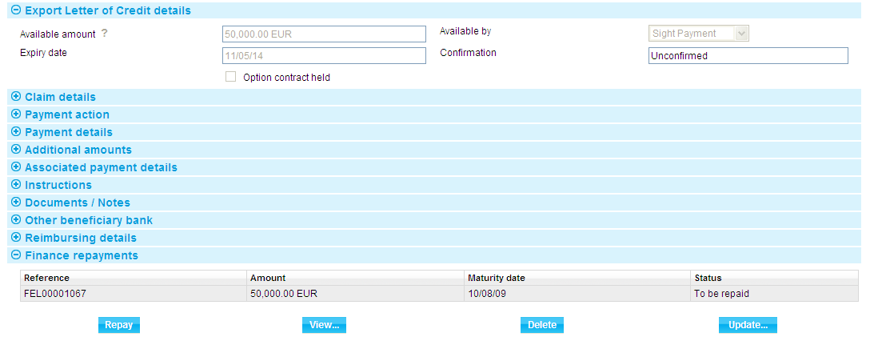

To repay a loan, highlight it, then press **Repay**.

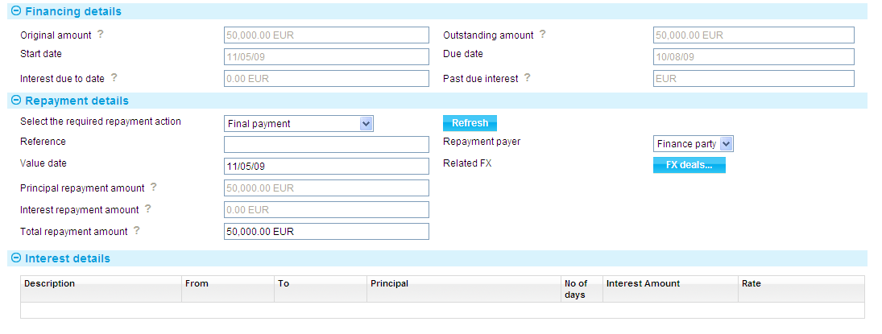

In the window that is displayed, enter details of the repayment. This is done in the same way as for a manual repayment (see Chapter 4) with the exception that there may be an additional payment action - Minimum Repayment. This is controlled by the MinimumRepaymentDefaultAmt system option. If the Minimum Repayment action is enabled it is used as the default value.

If you select this payment action, the system calculates the minimum payment required using the following formula:

|  |  |  |
| --- | --- | --- |
| outstanding financed amount | X | current payment amount |
| outstanding transaction amount |  |  |

where the outstanding financed amount includes all financing loans against the transaction (excluding loans created at part payment level, such as discounted deals), and the outstanding transaction amount excludes interest, tolerance and additional amounts (for example the letter of credit available amount).

The minimum repayment amount is then displayed in the Principal Amount field. If the minimum repayment amount is greater than the outstanding balance of the loan, then the outstanding balance is displayed instead.

With the payment action set to Minimum Repayment you will not be able to amend the amount in the Principal Amount field. If you wish to amend this amount, you can do so by setting the payment action to Other.

If the repayment amount has been discounted, then the discounted amount may also be used to calculate the minimum repayment amount and to repay an existing transaction.

When you close this window, the repayment details are shown in the Finance Repayments pane.

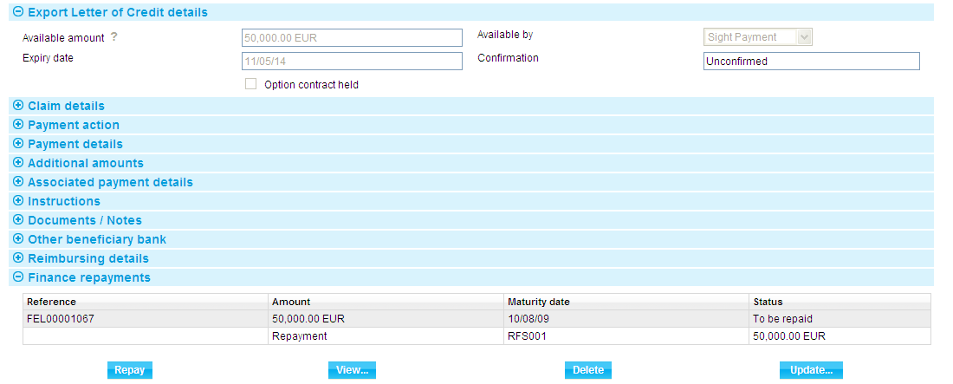

You can use the View, Update and Delete buttons to view, amend or delete the repayment details.

## Repaying Financing for Clean Bankers Acceptances

You can only repay the financing for a clean bankers acceptance by processing the acceptance's Sell, Early Repay, or Mature events. You cannot make repayments from the financing transaction's master record.

These events automatically cause the financing transaction to be repaid (if it is still outstanding). In the case of a partial early repayment of the acceptance, the financing transaction is similarly repaid in part; otherwise, it is fully repaid.

# Overdue Transactions

If a financing transaction reaches the end of its term and has not been repaid in full, it remains open for manual repayment until final payment is made.

The system handles overdue discounted bills and interest-bearing financing transactions differently.

If a discounted bill becomes overdue, it simply remains on the system until it is repaid in full.

For interest-bearing financing transactions, once the transaction has been released, the system creates an entry in the diary for the due date for the transaction. When this is reached, if the transaction has not yet been paid in full, the system creates a Past Due event in the Work in Progress pane. You can use this event to enter or confirm the penalty premium rate to be applied to the overdue portion of the advance.

When you open a Past Due event the window used shows details the financing amount and term and the type of interest, and the principal and interest amounts overdue.

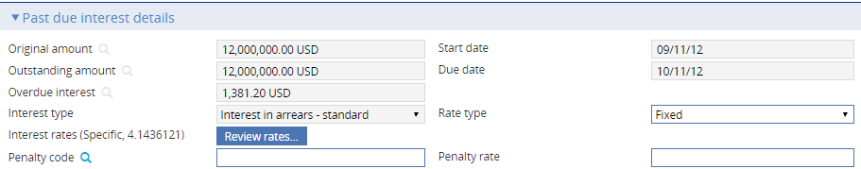

If you set up a penalty interest rate when first defining the financing transaction, this will be displayed using the Penalty Code or Penalty Rate fields. You can amend this, or enter a penalty interest rate, if none has been set up. Either select a predefined code using the first field or enter the rate to be applied in addition to the normal rate using the second field.

Interest accrued from financing transactions is not consolidated from past due for the automatic debiting of interest accounts. Accrued interest of this sort is instead collected when repayment is made.

1. The Past Due event takes account of all repayment events completed at the point at which it is generated. If a repayment event is in progress but not completed when you open a Past Due event a warning message to that effect is generated. In such a case you can, if appropriate, reject the Past Due event and then complete the repayment event.

After the Past Due event has been released, the financing transaction remains on the system, accruing interest at the interest plus penalty premium, until it is paid in full.

Past due interest can be capitalised for all financing transactions except discount and discount to yield based transactions. Where past due capitalisation is set for the transaction, the relevant tick-box is presented as read-only on the past due event screen. The past due event indicates interest is capitalised in the Interest due to date description text, also available for customer statements.

## Past Due Transfer

A final scheduled repayment is automatically created if the transaction is not fully paid off by the maturity date. If this repayment is rejected, and if the relevant product type is so configured, the system automatically transfers the overdue loan to a different account, creating a diary entry for a Past Due Transfer event for the number of days forward specified by the Transfer Overdue Accounting product option.

1. See the System Tailoring User Guide – Trade Innovation for information on product options.

# Transferring an Advance to a New Financing Transaction

The system permits you to transfer the outstanding principal amount of a financing transaction over to a new financing transaction as part of a manual repayment event. The new transaction will be of the same product (for example, Finance Inward Collection or Finance Outward Collection) as the original financing transaction, but may have a different product type.

When transferring principal and interest to a new loan you will not be able to change the currency - interest is transferred as an adjustment, which is added to the interest on the new loan, which may be in the different currency to the original financing transaction. When you do this, the system matures the original transaction, and carries the total outstanding principal amount over to the new financing transaction, together with any outstanding charges. The system also calculates any interest due, which you can collect as part of the payment event or defer until the payment date of the new transaction.

The new financing transaction is then processed independently. The Cross Ref button in the Master Summary window for the new financing transaction will show the financing transaction from which it was created.

Upon release of the manual repayment event, the status of the old financing transaction is set to *BKF* (booked off) after the final interest calculation has been carried out during end of day, and no back valuation is allowed on it beyond the transfer date.

1. You cannot transfer financing from one clean bankers acceptance over to another.

## Transferring an Advance

To transfer an advance, in the Master Summary window select 'Repay' from the Create New Event drop-down list and press **Create**. The system opens the event at either a Log step or Input step. Depending on how your system is configured, panes and fields available in log steps can be tailored for each data capture step. See the S*DK - Screen Tailoring Guide – Trade Innovation* for details.

If appropriate, use the Reference field to enter a reference for the repayment, then select 'Last pay then transfer' in the Action field and press **Refresh**.

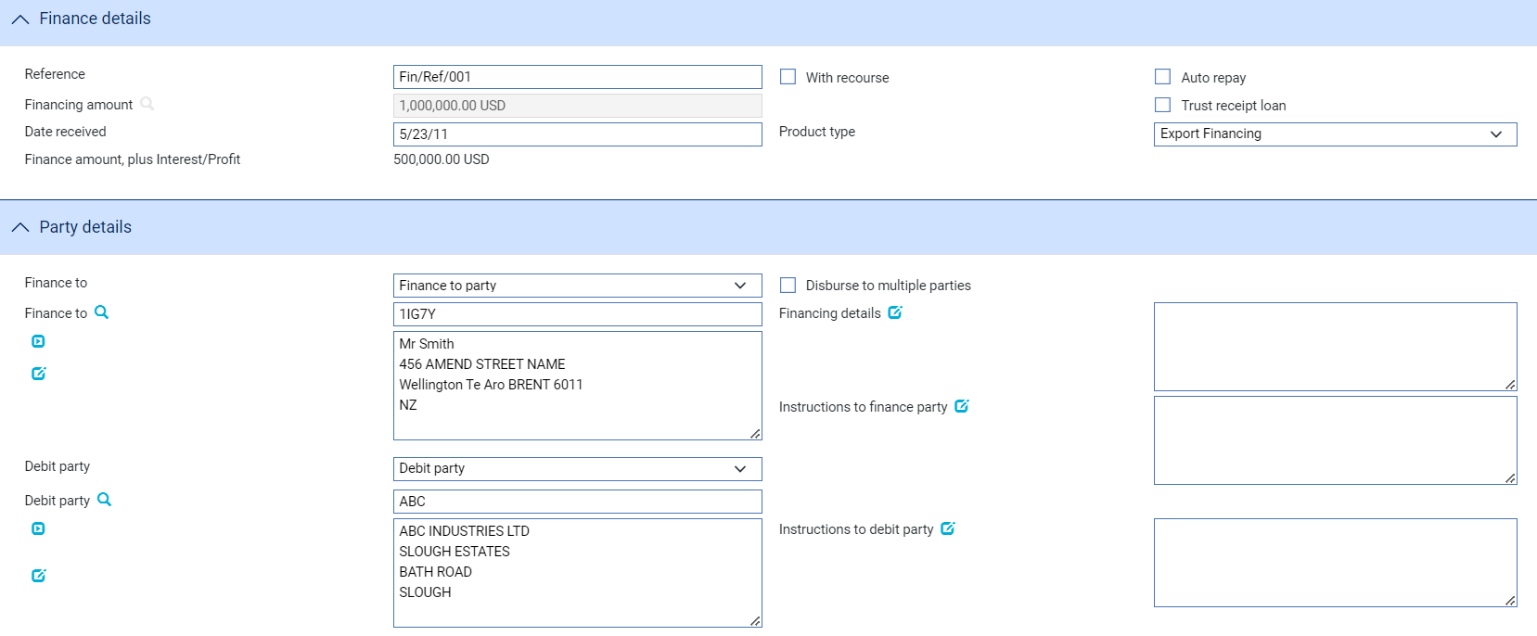

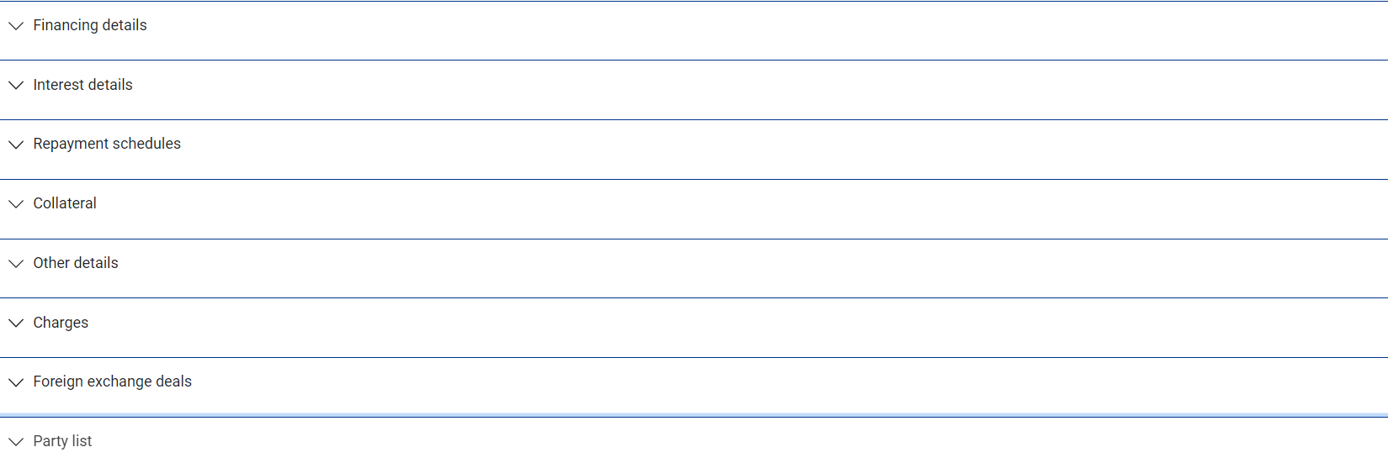

The Value Date field displays today's processing date, which you can overtype, if required.

The system displays the outstanding principal and interest in the Principal Amount and Interest Amount fields respectively. The Total Repayment Amount field shows the sum of these two figures, which is the amount needed to fully repay the advance.

The system permits you to transfer all or part of the outstanding principal and/or the interest due to the new financing transaction using a different currency. If you wish to make a payment of interest and/or principal to reduce the outstanding amounts before effecting the transfer, enter the amounts to be collected into the Interest Repayment Amount and Principal Repayment Amount fields and press **Refresh**. The system calculates any underpayment and displays details using the Principal Amount and Interest Amount fields.

If you wish to transfer the loan to a different currency, enter the currency into the Transfer Currency field. This enables the Exchange Rate – Principal and Exchange rate – Interest field filters. Manually enter the appropriate foreign exchange rate, or filter for a Rate code, using the browser function, into the Exchange Rate – Principal and Exchange Rate – Interest fields. You may specify different exchange rates.

1. The Transfer Currency field is used to specify the currency of the new loan that is created when the existing loan is transferred. This field defaults to the original financing currency. You must enter the currency into which the loan will be transferred.

The Exchange Rate – Principal and Exchange Rate – Interest fields are used to enter the appropriate foreign exchange rate or rate code. These fields enable transfer of Principal and Interest. You can specify different exchange rates for Principal and Interest.

Any underpayment of principal is transferred to the new financing transaction as the transaction's finance amount, and any underpayment of interest is transferred to the new financing transaction as an interest adjustment to be collected together with interest due on the new transaction.

For financing transactions with interest in advance, a principal repayment before the due date, or before the next interest period, will result in an overpayment of interest. In such a case the system will display the refund due in the Interest Overpaid field.

If required, use the buttons in the Repayment Payer field to amend which party is making the repayment.

When you have competed input in this window, press **Transfer** to enter details for the new financing transaction.

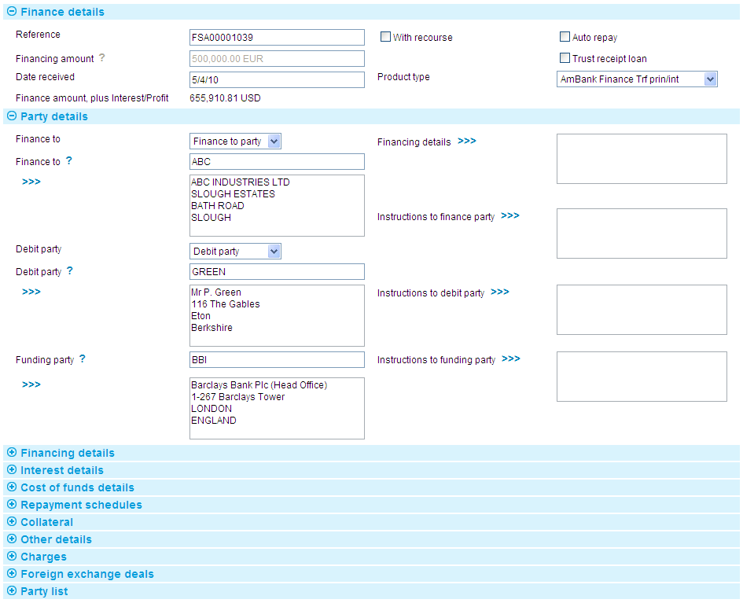

The window displayed allows you to enter details of the new financing transaction in the way described in Chapter 2.

Note that the new transaction, by default, has the same reference, finance to and debit parties as the original. You can change these. It will also be the same type of product as the old financing transaction, which you cannot change.

The Financing Amount field shows the outstanding principal amount of the old financing transaction, and by default the amount of the advance is the amount carried over from the old transaction. You can increase this amount, but it cannot be less than the amount carried over from the old financing transaction.

Field characteristics and system behaviour when Repay event is created via gateway with Repayment Action of Last pay then transfer.

| Field | Present | Valid | Decision | Allow to Edit |
| --- | --- | --- | --- | --- |
| Reference | Y/N | - | Add to field | Y |
| Value date | Y | Y | Add to field | Y |
| Y | N | Action item requiring review |
| N | - | System pre-filled |
| Principal repayment amount | Y | Y | Add to field | Y |
| Y | N | Action item requiring review |
| N | - | System pre-filled |
| Interest repayment amount | Y | Y | Add to field | Y |
| Y | N | *Interest repayment amount is validated against the ‘Interest due to date’ which may bring out additional field, Interest underpaid/overpaid amount.* |
| N | - | System pre-filled |
| Total repayment amount | Y/N | Y | System pre-filled | N |
|  | Y | N | Action item requiring review |  |
| Repayment payer | Y | Y | Display selection | Y |
| Y | N | Action item requiring review |
| N | - | System default |
| Transfer currency | Y | Y | System default | Y |
| Y | N | Action item requiring review |
| Exchange Rate – Principal | Y/N | Y/N | Action item requiring review | N |
| Principal amount | Y/N | Y/N | Action item requiring review | N |
| Exchange Rate – Interest | Y/N | Y/N | Action item requiring review | N |
| Interest amount | Y/N | Y/N | Action item requiring review | N |

Values from the gateway for other fields relating to interest (i.e. Next interest, Days basis, Base rate, Spread rate) are found in the Action items requiring review.

## After You Have Completed the Event

Once you have completed an Input step for the manual repayment event the system performs the necessary review and/or authorisation steps, as required by your system. The event is then released in the usual way.

Once the Manual Repayment event has been released, the system creates a new master record for the new financing transaction. This can be opened from within the Masters window and worked on independently.

# Amending a Financing Transaction

A financing transaction can be amended using an Amend Finance event at any time between the release of the event that creates it and its final payment date.

Amend Finance events can be carried out on financing transactions with interest in arrears or in advance to:

* Increase the amount of the advance (you can decrease the amount only by entering repayments against it)
* Where the transaction was created from within an export transaction, to enter a due date, once documents have been received
* To amend the repayment schedule
* To amend the interest consolidation flag and currency (for interest in arrears only)
* To change the user-defined analysis codes. If you change a code that is used for accounting purposes you must ensure that the appropriate reconciliations are made using a manual book-keeping event

You cannot amend a financing transaction that has been discounted. If the amendment increases the amount of a transaction that is already participated a Drawdown/Revolve Commit Amt event may be created as a subsidiary event to decrease the commitment amount available on the transaction.

If the AllowProjectionOnlyPostings system option is set to ‘Yes’, you can set up projection-only postings for the anticipated maturity date. Those projections will be reversed automatically if the amendment changes the maturity date.

Any changes you make take effect upon release of the amendment event. Any existing diary actions for the financing transactions are adjusted to reflect the amendment.

1. If the product type of the transaction is changed this will not result in changes to the transaction. If the user really requires these major changes then the current transaction should be closed off with the 'Last pay and transfer' action in the payment event and the new product type would then be used to set up the follow on financing transaction.

## Licenses

If the amendment increases the amount of a transaction associated with a license, then a drawdown must be made to cover the increased amount. This may occur automatically if only a single license is linked or you are required to manually allocate the increased loan amount where there are several linked licenses. You can also link in another license to cover the shortfall. The amended due date must be before the license Valid To date.

If you amend the product type, then the new type will be validated to ensure the license type is valid for the new product type.

See the Licenses User Guide – Trade Innovation for details of licenses.

## Handling More Than One Amendment at a Time

The system permits you to have more than one amendment event in progress for a master at the same time. If you attempt to open an amendment event for a financing transaction that already has an amendment event in progress, the system will warn you of the fact, but will allow you to continue. When the amendment event is created or opened at an Input step, the system will show the current details held for the master.

If your system is configured so that amendment events need to be reviewed before release, then during these later steps the supervisor will be advised of the existence of another amendment event that has completed while the current event has been at the Review step. They can then decide how each amendment event should be handled to ensure that the required changes are implemented.

## Amending a Financing Transaction

The same procedure is followed for all types of financing transaction. In the Master Summary window select 'Amend Finance' from the Create New Event drop-down list. The system opens the event at either a Log step or Input step (see page 68), depending on how the Workflow orchestration controlling the event is configured. See the Workflow Tailoring User Guide – Trade Innovation for details.

### Logging an Amendment

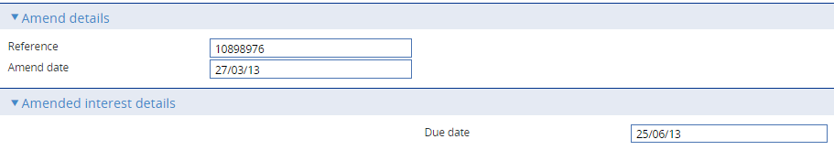

The following table explains what to enter the fields in the window used to log an amendment:

|  |  |
| --- | --- |
| Field | What to Enter |
| Reference | The finance party's reference for the financing transaction. |
| Amend Date | The date of the amendment. The system uses today's date as the default. |
| Due Date | If appropriate, the new due date for the financing transaction. You can only change this date before the transaction's past due date has been reached. |

### Entering Full Details of the Amendment

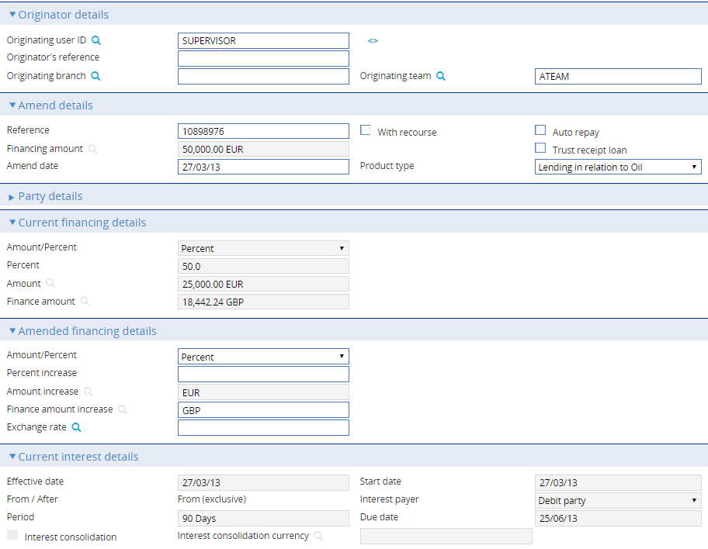

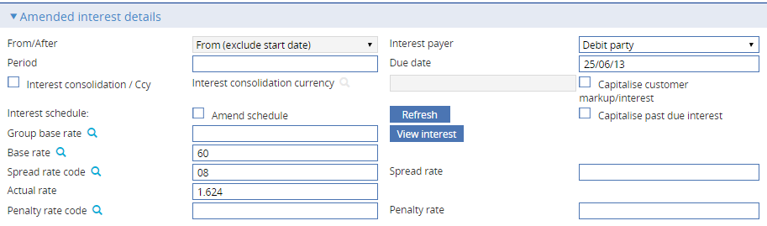

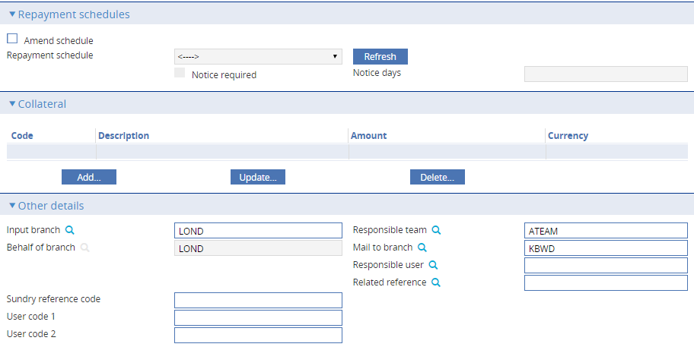

If the financing transaction is linked to an export credit agency facility an additional pane - the Cost of Funds Details pane - is displayed.

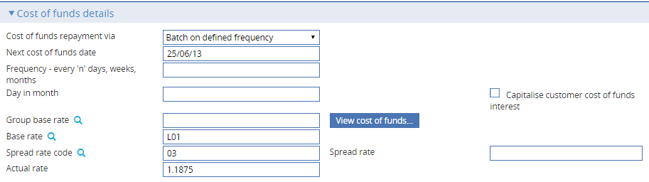

The system displays a sub-set of the information entered when the financing transaction was created, and you can amend it.

Enter the date of the amendment into the Amend Date field - today's date is used as the default.

For financing and interest details the system displays the current details, and provides a second set of fields for you to enter new details.

To amend the repayment schedule, check the Amend Schedule field and press **Refresh**. You can then amend repayment schedule details.

For regular schedules, you can use the First Repayment field to set the date the next principal repayment is due; and the Frequency fields to define the frequency of repayments thereafter.

For irregular schedules, you can add new entries or amend and delete existing ones in the same way as when you first created the schedule.

The View Interest button in the Amended Interest Details pane and the View Cost of Funds button in the Cost of Funds Details pane display a window that shows details of the interest calculated on the financing transaction.

The window shows the interest rates applied to the principal amount during different periods of the term, and the resulting interest due in each period of the loan, taking into account the proposed principal repayment.

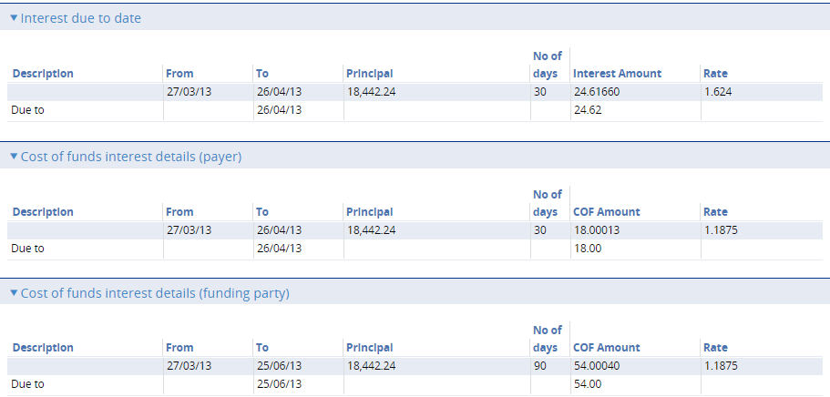

Information is provided for your bank's own interest. If the financing transaction is linked to an export credit agency facility, information is also provided for cost-of-funds interest for the export credit agency.

## Making Adjustments to the Master Record

The Amend Finance event allows you to make all the changes that are likely to be required in the normal course of business. The system also includes an Adjust Finance event, which contains additional functionality to allow you to make changes to most of the information recorded for a financing transaction.

The Adjust Finance event is designed to allow you to make changes where you need to alter details but do not need to notify other parties.

Once you have initiated an adjustment event, the system will prevent you from opening any other event for the transaction until the adjustment event has completed. If you attempt to open an Adjust Finance event while another event for the master is in progress, the system will warn you of the fact and prompt you to abort the adjustment event. Unless you are attempting to make an adjustment to allow the pre-existing event to complete, you should abort the adjustment event and wait until the pre-existing event has completed before attempting the adjustment event again. If you continue with the adjustment event, then the system will prevent any further work on the pre-existing event until the adjustment event has completed.

1. This functionally is intended to allow you to correct mistakes, and should be used cautiously. If you make any changes using this functionality, you should ensure that the proper reconciliations are carried out.

During an Adjust Finance event, you can view charges and add optional charges, but cannot edit existing charges. To change charges, you should use a Maintain Charges event.

With the appropriate master record open, in the Master Summary window select 'Adjust Finance' from the Create New Event drop-down list and press **Create**. The system opens the event at either a Log step or Input step. Depending on how your system is configured, panes and fields available in log steps can be tailored for each data capture step. See the *SDK - Screen Tailoring Guide –Trade Innovation* for details.

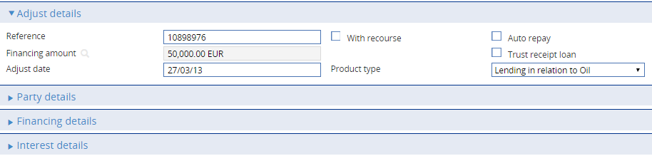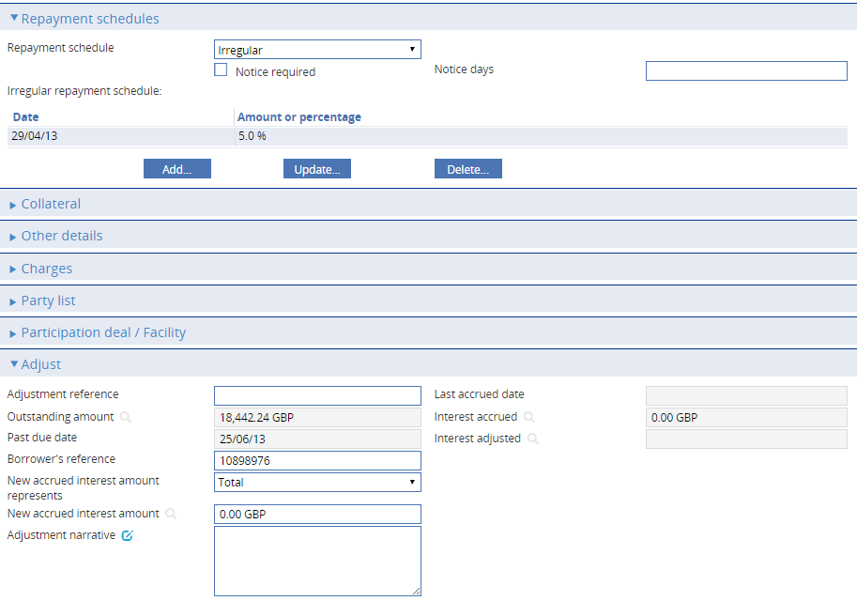

If the financing transaction is linked to an export credit agency facility an additional pane - the Cost of Funds Details pane - is displayed.

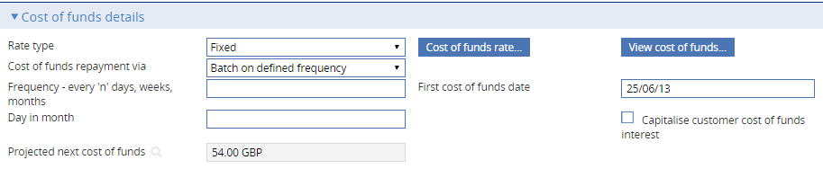

The window displays information already entered for the financing transaction, which you can overtype. An Adjust Date field allows you to enter the date the adjustment was made.

The Adjust pane displays some additional fields. The table below explains what each of these fields show, and the implications of changing the values in those fields that permit input.

|  | Field | What to Enter |
| --- | --- | --- |
|  | Adjustment Reference | Your bank's reference for the adjustment. |
|  | Outstanding Amount | Displays the outstanding principal amount. |
|  | Past Due Date | Displays the past due date calculated for the transaction prior to this amendment. |
|  | Borrower's Reference | Displays the borrower's reference for the transaction. |
|  | New Accrued Interest Amount Represents | Specify whether the New Accrued Interest Amount holds the amount of interest accrued for the transaction so far (select 'Total'); or an amount to be added to the current amount of interest accrued for the transaction (select 'Adjustment'). |
|  | New Accrued Interest Amount | The system displays the amount of interest accrued for the transaction so far. You can amend this figure, either to show a new total amount accrued, or to show an amount to be entered to the current amount of interest accrued for the transaction, depending on the setting of the New Accrued Interest Amount Represents field. |
|  | Adjustment Narrative | The reason why the adjustment was made. |
|  | Last Accrued Date | For financing transactions with interest in arrears only, the date on which interest was last accrued. |
|  | Interest Accrued | For financing transactions with interest in arrears only, the amount of interest accrued for the transaction so far. |
|  | Interest Adjusted | For financing transactions with interest in arrears only, this displays any adjustment made to interest in the previous Adjust event. If there was no change to interest in the last Adjust event, this field will be blank.  This field can be used when taking existing transactions on to the system, to set the interest accrued to date without needing to input the past history of rate changes. Thereafter, the resulting figure is used only in calculating the interest due. |

The View Interest button in the Amended Interest Details pane and the View Cost of Funds button in the Cost of Funds Details pane display a window that shows details of the interest calculated on the financing transaction.

The Cost of Funds button in the Cost of Funds Details pane displays a window used to enter details of the rates to be used for cost-of-funds interest calculations.

The window shows the interest rates applied to the principal amount during different periods of the term, and the resulting interest due in each period of the loan, taking into account the proposed principal repayment.

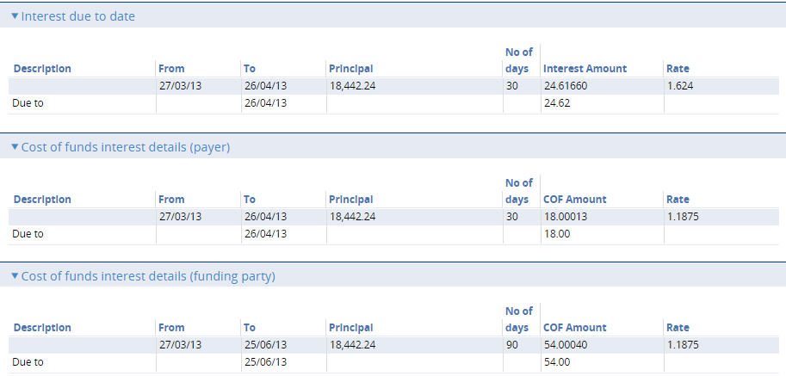

Information is provided for your bank's own interest. If the financing transaction is linked to an export credit agency facility, information is also provided for cost-of-funds interest for the export credit agency.

# Repayment Notices

When you first enter details of a financing transaction, the system permits you to define schedules determining the repayment of interest and principal amounts. For each type of schedule, if the party making repayment requires notification of a repayment before it falls due, you can also specify how soon before repayments notices are to be produced.

The system uses these schedules to create diary entries for the financing transaction which automatically generate the required notices on the appropriate dates.

For more information on setting up the schedules governing when notices are produced see Chapter 2.

The same event - the Advise Repayment event - is used to advise parties of interest repayments and principal repayments. If a notice for an interest repayment and a notice for a principal repayment fall due on the same day, and the same party is to repay both interest and principal amounts, the system produces a single notice to cover both repayments.

The Advise Repayment event can be configured to be generated and released automatically, requiring no manual intervention. Alternatively, it can be configured so that it requires input, review and/or authorisation before it can be released, in which case the system generates an event at the appropriate step and lists it in the Work in Progress pane in the Summary window for the financing transaction.

You must then manually intervene by opening the event and completing it before the notice can be released.

1. There is no dependency between the Advise Repayment event and the associated repayment event. The repayment event is unaffected if you reject or fail to complete its associated Advise Repayment event.

For information on the diary facility see the Common Facilities User Guide – Trade Innovation.

## Manually Completing a Repayment Notice

If you open an Advise Repayment event at an Input step the system permits you to enter a reference for the notice into the Reference field, and to amend which party is to make the repayment using the buttons in the Repayment Payer field.

By default the Send Advice box is checked, indicating that the advice can be sent. However, you can uncheck this box if you decide not to send the notice, for example if a repayment schedule is currently being renegotiated.

The Advise Repayment event uses one of two windows, depending on whether the bill is interest-bearing or has been discounted (see page 36).

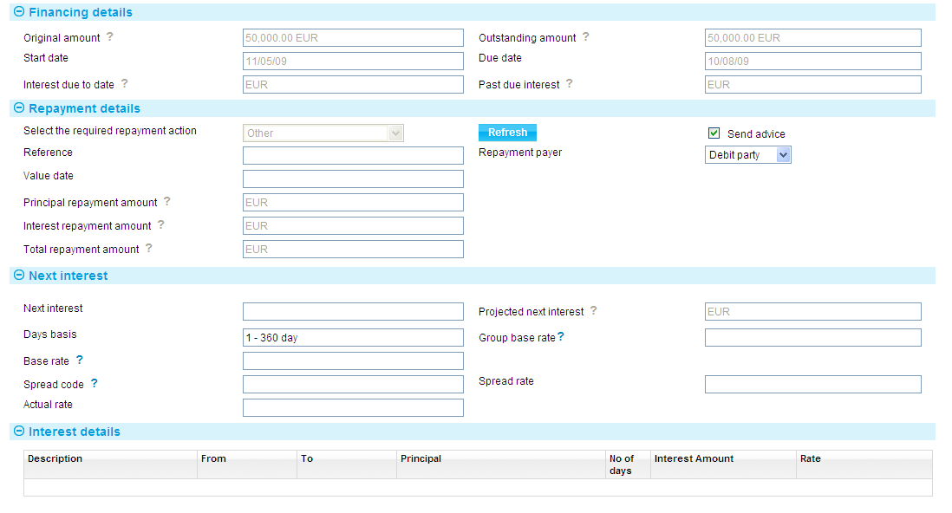

If the financing transaction is linked to an export credit agency facility an additional pane - the Cost of Funds Details pane - is displayed.

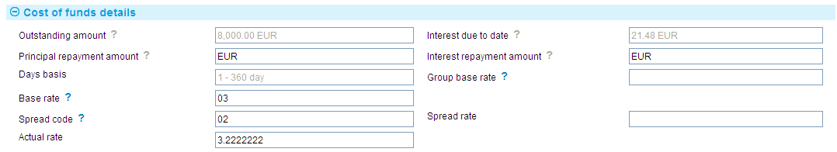

This pane displays details of the values used in calculating cost-of-funds interest for the export credit agency and the principal amount and the interest amount to be paid to the agency.

### For Interest-bearing Transactions

For a financing transaction with interest in arrears or in advance the Financing Details pane shows details of the advance, including:

* The original finance amount
* The amount outstanding
* The term of the advance
* The interest due to date
* The past due interest

The Repayment Details pane shows details of the repayment required. For a principal repayment, it will show the value date of the repayment and the principal amount to be repaid. For an interest repayment, it will show the value date of the repayment and the interest amount due.

The Interest Details pane shows, for interest repayments, the date the next interest repayment is due and the projected next interest amount.

### For Discounted Bills

For discounted bills, the Financing Details pane shows details of the advance, including:

* The original finance amount
* The amount outstanding and its currency
* The term of the advance
* The due date

The Repayment Details pane shows the value date of the repayment and the principal amount to be repaid.